**Final Year Project Report**

**AI ENHANCED COLLABORATIVE RESEARCH HUB**



**Project Advisor: Mr. Jawad Farooq**

**Co- Advisor: Mr. Muhammad Adeel**

**Submitted By:**

**Kainat Munir F2021065261**

**Fatima Ghaffar F2021065260**

**Minahil Fatima F2021065238**

**Hajira Nadeem F2021065246**

**Sana Bibi F2021105211**

**Session 2021-2025**

**University of Management and Technology**

**C-II Johar Town Lahore Pakistan**

**Dedication**

I thoughtfully dedicate this Final Year Project to my **parents**, whose infinite love, sacrifices, and support have been my utmost inspiration. Their unshakeable faith in me has been an illuminating ray of guidance throughout this way. I also acknowledge this effort from my esteemed supervisor **Mr.Jawad Farooq** and co advisor **Mr. Adeel**, whose support and advice have been of immense value in my making this project a success. In addition, I dedicate this to my peers and friends, who have assisted me with their encouragement, wisdom, and inspiration throughout this difficult yet fulfilling exercise. Most importantly, I thank the **Almighty** for granting me the strength and patience to finish this work.

**Final Approval**

* **Head of Department**  ______________________

Department of Software Engineering

School of Systems & Technology

UMT Lahore

* **Director (Final Year Projects-CS)** ______________________

Department of Computer Science.

School of Systems & Technology

UMT Lahore

* **Supervisor** ______________________
* Department of Computer Science.
* School of Systems & Technology

UMT Lahore

* **Co-Supervisor** ______________________

**Acknowledgment**

Most of all, I am deeply thankful to  **Allah** for providing me with the strength, patience, and perseverance to successfully finish this project. Without His numerous blessings, this would not have been achievable. I would like to thank my supervisor, **Mr. Jawad Farooq**, and co-advisor, **Mr. Muhammad Adeel**, with all my heart for their unrelenting support, priceless guidance, and constant encouragement throughout this experience. Their perceptive recommendations, critical comments, and experience have played a crucial role in the direction of this project. Their guidance not only assisted me in overcoming obstacles but also enabled me to develop academically and professionally. I am indebted to my family and parents, whose unrelenting support, prayer, and love have been my single largest source of inspiration. Their faith in my capabilities has set me strong enough to push through problems and aim for perfection. If it were not for them, it would have been much tougher. I want to extend my warm gratitude to my friends and fellow classmates for their support, discussions, and teamwork during this exercise. Their openness to share information, exchange ideas, and offer encouragement was instrumental to the successful accomplishment of this project. Finally, I would like to express gratitude to all those who, in any form, contributed to this project whether by advice, support, or technical assistance. Your efforts, however significant or insignificant, have been hugely worthwhile. I am deeply thankful for having had the chance to do this project and for all the assistance I was given.

**Project Title** AI Enhanced Collaborative Research Hub

**Objective** The objective of this project is to design an Enhanced Collaborative Research Hub to facilitate researchers in collaborating more conveniently. It will consist of document sharing tools, discussions, and project management. Features driven by AI such as intelligent recommendations and trend analysis will offer beneficial insights. The system will also provide data security and have a simple interface to be used on both desktop and mobile platforms.

**Undertaken by** We hereby confirm that this Final Year Project (FYP), "AI Enhanced Collaborative Research Hub," is our own work. We have not plagiarized or reproduced any aspect of this project from any other source. All the content, research, design, and implementation has been done by us under the supervision of our supervisor Mr. Jawad Farooq and co-advisor Mr. Muhammad Adeel.

This project has been completed as part of our Software Engineering curriculum and is done according to ethical and academic integrity guidelines.

Completed By:

Kainat Munir

Fatima Ghaffar

Hajira Nadeem

Minahil Fatima

Sana Bibi

**Supervised by** Mr. Jawad Farooq

**Starting Date** 25 October 2025

**Completion Date**

**Tools Used** JavaScript, node.js, MongoDB, Python

**Operating System**

**Documentation**

**Abstract**

The AI Enhanced Collaborative Research Hub is a platform intended to facilitate easier and more effective research collaboration. It offers tools for document sharing, discussion, and project management in a single location. Utilizing AI and machine learning, it provides smart recommendations, summarization to enable researchers to locate useful information in a matter of seconds. The system further incorporates version control, data visualization, and security features to ensure research data safety. With an easy and user-friendly interface, researchers can collaborate comfortably from any device. This project is designed to bridge research teamwork challenges and enhance the research process as a whole.

Revision Chart

| Version | Primary Author(s) | Description of Version | Date Completed |
| --- | --- | --- | --- |
| Draft | Kainat Munir, Fatima Ghaffar, Minahil Fatima, Hajira Nadeem, Sana Bibi | Initial draft created for distribution and review comments | 15-Dec-2024 |
| Preliminary | Kainat Munir | Second draft incorporating initial review comments, distributed for final review | 2-Jan-2025 |
| Final | Fatima Ghaffar, Sana Bibi | First complete draft, which is placed under change control | 17-Jan-2025 |
| Revision 1 | Minahil Fatima | Revised draft, revised according to the change control process and maintained under change control | 29-Jan-2025 |
| Revision 2 | Hajira Nadeem | Revised draft, revised according to the change control process and maintained under change control | 7-Feb-2025 |

# Contents

Contents

Contents 8

Definitions and Acronyms 10

List of Figures 11

List of Tables 13

1. Introduction 14

1.1 Motivation: 14

1.2 Project Overview 14

1.3 Problem Statement 14

1.4 Objectives 14

2. Domain Analysis 15

2.1 Customer 15

2.2 Stakeholders 15

2.3 Socially or economically affected groups 15

2.4 Dependencies/ External Systems 16

2.5 Reference Documents 16

2.5.1 Related Projects 16

2.5.2 Feature Comparison 16

3. Requirements analysis 18

3.1 Requirements 18

3.2 List of Actors 22

3.3 List of use cases 25

3.3.1 Use Case 1: User Registration 25

3.3.2 Use Case 2: User Login and Authentication 25

3.3.3 Use Case 3: Create a Research Project 26

3.3.4 Use Case 4: Upload and Share Research Documents 27

3.3.5 Use Case 5: AI-Powered Research Paper Summarization 28

3.3.6 Use Case 6: Join and Participate in Discussion Forums 28

3.3.7 Use Case 7: Secure Data Backup and Recovery 29

3.4 System use case diagram 30

3.5 Extended use cases 37

3.6 User interfaces (mock screens) 48

4. Data Flow Diagram 55

4.1 Data Flow Diagram Level 0 55

4.2 Data Flow Diagram Level 1 55

4.3 Data Flow Diagram Level 2 56

5. SYSTEM DESIGN 57

5.1 System Architecture Diagram 57

5.2 Class Diagram 57

5.3 Sequence Diagram 57

5.4 Object Sequence Diagram 67

5.5 ERD 74

5.6 State Design 74

5.7 Activity Diagram 79

79

5.8 Polymorphism Diagram 79

5.9 Realization Diagram 80

6. IMPLEMENTATION 81

6.1 SCREEN N0 1: 81

6.2 SCREEN N0 2: 82

82

6.3 SCREEN N0 3: 82

6.4 SCREEN N0 4: 83

6.5 SCREEN N0 5: 85

6.6 SCREEN N0 6: 86

6.7 SCREEN N0 7: 87

87

6.8 SCREEN N0 8: 88

6.9 SCREEN N0 9: 89

6.10 SCREEN N0 10: 90

6.11 SCREEN N0 11: 91

6.12 SCREEN N0 12: 92

6.13 SCREEN N0 13: 93

6.14 SCREEN N0 14: 95

6.15 SCREEN NO 15: 96

6.16 SCREEN NO 16: 98

7. AI IMPLEMENTATION 99

7.1 AI-Powered Research Paper Recommendation 99

7.2 AI-Powered Research Paper Summarization 99

## Definitions and Acronyms

Table 1:Definitions and Acronyms

|  |  |
| --- | --- |
| **Acronym** | **Definition** |
| UMT | University of Management and Technology |
| AI | Artificial Intelligence |
| ML | Machine Learning |
| MFA | Multi-Factor Authentication |
| NLP | Natural Language Processing |
| GDPR | General Data Protection Regulation |
| API | Application Programming Interface |
| MongoDB | A NoSQL database used for storing large amounts of unstructured data. |
| Node.js | A runtime environment for executing JavaScript code server-side. |

## List of Figures

Figure 1: User registration 23

Figure 2: User Login and Authentication 24

Figure 3: Create a Research Project 25

Figure 4: Upload and Share Documents 26

Figure 5: AI-Powered Research Paper Summarization 27

Figure 6: Join and Participate in Discussion Forums 28

Figure 7: Secure Data Backup and Recovery 29

Figure 8: Screen 1 41

Figure 9: Screen 2 41

Figure 10: Screen 3 42

Figure 11: Screen 4 42

Figure 12: Screen 5 43

Figure 13: Screen 6 43

Figure 14: Screen 7 44

Figure 15: Screen 8 44

Figure 16: Screen 9 45

Figure 17: Screen 10 45

Figure 18: Screen 11 45

Figure 19: Screen 12 46

Figure 20: Screen 13 46

Figure 21: Screen 14 46

Figure 22: Screen 15 47

Figure 23: Screen 16 47

Figure 24: Data flow level 0 48

Figure 25: Data flow level 1 48

Figure 26: Data flow level 2 49

Figure 27: System architecture 50

Figure 28: Class Diagram 50

Figure 29: User Registration (with Actor) 51

Figure 30: User Login and Authentication 52

Figure 31: Creating a Research Project 53

Figure 32: Uploading and Sharing Research Documents 54

Figure 33: AI-Powered Research Paper Summarization 55

Figure 34: AI-Powered Collaborator Matching 56

Figure 35: Secure Data Backup and Recovery 57

Figure 36: Research Discussion Forum (Post & Reply) 58

Figure 37: Pricing Management 59

Figure 38: User Registration (with Actor) 60

Figure 39: User Login and Authentication 61

Figure 40: Creating a Research Project 62

Figure 41: Uploading and Sharing Research Documents 62

Figure 42: AI-Powered Collaborator Matching 63

Figure 43: AI-Powered Research Paper Summarization 63

Figure 44: Secure Data Backup and Recovery 64

Figure 45: Research Discussion Forum (Post & Reply) 65

Figure 46: Pricing Management 66

Figure 47: ERD Diagram 67

Figure 48: User Registration 68

Figure 49: User Login & Authentication 69

Figure 50: Research Project Creation 69

Figure 51: Uploading & Sharing Research Documents 70

Figure 52: AI-Powered Research Paper Summarization 70

Figure 53: AI-Powered Collaborator Matching 71

Figure 54: Joining & Participating in Discussion Forums 71

Figure 55: Secure Data Backup & Recovery 72

Figure 56: Pricing Management 72

Figure 57: Activity Diagram 73

Figure 58: Polymorphism Diagram 73

Figure 59: Realization Diagram 73

## 

## List of Tables

Table 1:Definitions and Acronyms 3

Table 2: list of stakeholders 8

Table 3: Feature comparison 9

Table 4: Functional Requirement 11

Table 5: Non Functional Requirements 13

Table 6: Data Requirements 14

Table 7: Constraint 14

Table 8: External Interface Requirement 15

# Introduction

## Motivation:

With the fast-changing environment of academic and industrial research, collaboration has emerged as a building block for innovation and advancement. Researchers from various disciplines and locations frequently struggle to share knowledge in an efficient manner, coordinate projects, and have open communication. Even with advances in technology, the absence of a unified platform to enable easy collaboration slows down the research process. By eliminating these inefficiencies, this project seeks to deliver a revolutionary solution that empowers researchers, increases productivity, and stimulates meaningful results.

## Project Overview

The Advanced AI Collaborative Research Hub is a cross-platform solution that is meant to facilitate research collaboration. It integrates core features like document sharing, discussion boards, and versioning with AI and machine learning to offer intelligent recommendations, automated literature reviews, and collaboration matching. The platform seeks to make the research process more effective by providing efficient project management tools, data analytics, and communications within a secure, user-friendly environment.

## Problem Statement

Today's research teams usually face isolated tools and less-than-optimal workflows. Researchers use separate platforms for sharing documents, communication, and version control, which causes issues such as:

* Tedious processes for document updating and sharing.
* Few channels of communication that are unable to capture the dynamic requirements of research teams.
* Waste of time in project version management, leading to data loss and confusion.
* No AI-powered insights to determine relevant resources and collaborators.

These problems affect research productivity, quality, and collaboration potential, highlighting the importance of a harmonized and intelligent solution.

## Objectives

1. Improve Research Collaboration: Create a platform that brings together key tools for smooth document sharing, discussion forums, and project management.
2. Leverage AI and Machine Learning: Incorporate advanced features like smart recommendations, trend analysis, and automated literature reviews to enable researchers with actionable insights.
3. Streamline Research Processes: Offer version control, data visualization, and collaborative analysis functionalities to make complex workflows easier.
4. Ensure Security and Compliance: Incorporate strong security features and compliance regulations to safeguard sensitive research information.
5. Facilitate User Accessibility: Create an easy-to-use interface with mobile accessibility to support a wide variety of researchers.

Through these goals, the Enhanced Collaborative Research Hub will overcome existing challenges and redefine researcher collaboration and innovation.

# Domain Analysis

## Customer

1. Academic Researchers: Faculty members, graduate students, and postdoctoral researchers who need software for managing research initiatives, working with colleagues, and data analysis.
2. Industry Researchers: R&D professionals in technology, pharmaceutical, and engineering industries.
3. Research Institutions: Research centers, universities, and think tanks that need central systems to facilitate team collaborations and big projects.
4. Policy Makers and Analysts: People who study and use research to make decisions and formulate policies.
5. Entrepreneurs and Innovators: Startups and people looking to exploit research for creative solutions and collaboration.

## Stakeholders

Table 2: list of stakeholders

|  |  |
| --- | --- |
| Stakeholder | Role In System |
| Researchers | The primary users of the platform who benefit directly from its features. |
| Research Institutions | Organizations investing in collaborative tools to enhance research outcomes. |
| Funding Agencies | Interested in tools to monitor and evaluate research progress. |
| Scientific Publishers | Utilizing features like automated document classification to improve publication workflows. |
| Governments and NGOs | Benefiting from insights generated through enhanced research capabilities. |
| Tech Companies | Providing infrastructure or partnering for further development and deployment |

## Socially or economically affected groups

1. **Research Teams:** Enjoy greater efficiency and productivity in their work.
2. **Students**: Have easier access to resources and groupware for projects.
3. **Librarians and Publishers**: Use improved search and classification functionality to improve their processes.

**Social Impact**

* Fosters interdisciplinary research, creating a knowledge-sharing culture.
* Enhances access to state-of-the-art tools for researchers in low-resource regions.
* Aids in society's progression through the speeded-up discovery and innovation of research.

**Economic Impact:**

* Improves productivity and efficiency, saving time and expenses in research practices.
* Spurs innovation, generating new products, services, and technologies that drive economic growth.
* Aids industries based on research and development, raising their competitive advantage.

The Advanced Collaborative Research Platform is set to deliver substantial advantages to its end-users, stakeholders, and wider society, rendering it an imperative instrument for pushing forward research and innovation.

## Dependencies/ External Systems

1. Cloud Services: Reliance on hosts such as AWS for deployment and hosting.
2. Database Systems: MongoDB for data storage and management.
3. AI and Machine Learning Libraries: Libraries such as PyTorch for the enactment of sophisticated AI/ML functionality.
4. Task Management Tools: Integration with Jira for effective project tracking.

## Reference Documents

1. Documentation of prior research collaboration tools.
2. AI and data privacy standards (e.g., GDPR compliance documents).
3. MongoDB and Bootstrap development tutorials.
4. Academic reference for AI-based collaboration platforms.

### Related Projects

1. File Management Systems (FMS): Tools for effective document storage and retrieval.
2. Bibliographic and Historical Management Systems (BHMS): Platforms for bibliographic record and historical document management.
3. Collaborative Learning and Analysis Systems (CLAS): Systems dedicated to collaborative learning experiences and data analysis.

### Feature Comparison

Table 3: Feature comparison

|  |  |  |  |  |  |
| --- | --- | --- | --- | --- | --- |
| Sr  No. | Comparison Feature | FMS | BHMS | CIAS Remarks | Recommendation |
| 1 | User Authentication & MFA | Supports basic authentication, but MFA is optional | Lacks advanced authentication methods | Suggests implementing adaptive MFA for better security | Integrate **adaptive MFA** using behavioral authentication |
| 2 | Project Creation & Management | Allows document-based projects but lacks team collaboration | No dedicated project management module | Recommends role-based project structuring with automated tracking | Implement **role-based access control** and **activity tracking** |
| 3 | AI-Powered Research Summarization | No AI-driven summarization | No AI capabilities | Proposes NLP-based summarization for efficiency | Utilize **NLP models** like **BART/T5** for summarization |
| 4 | Collaborator Matching (AI Feature) | Does not offer AI-based matching | Lacks collaboration features | Suggests machine-learning-based recommendations | Use **ML algorithms** to suggest research collaborators |
| 5 | Discussion Forums & Knowledge Sharing | Provides basic document comments | No dedicated discussion forums | Recommends **threaded discussions** for structured conversations | Implement **real-time discussion forums** with topic categorization |

# Requirements analysis

## Requirements

Table 4: Functional Requirement

|  |  |  |
| --- | --- | --- |
| **NO** | **Requirement** | **Description** |
| FR1 | User Authentication and Authorization | The system shall provide secure authentication and authorization mechanisms to ensure that only registered users can access the platform. This includes: User **Registration:** Allow new users to create an account by providing necessary information such as username, password, email address, and affiliation.  **Login:** Enable users to log in using their username and password.  **Password Management:** Provide functionality for users to reset or change their passwords securely.  **Role-Based Access Control:** Assign roles (e.g., researcher, academic manager, administrator) to users, determining their access levels and permissions within the system. |
| FR2 | Document Sharing and Collaboration | **Document Upload:** Users shall be able to upload documents in various formats (e.g., PDF, DOCX).  **Document Sharing:** Users can share documents with other users and configure permissions (view, comment, edit).  **Real-Time Collaboration:** Real-time collaboration will be supported, enabling multiple users to edit the document simultaneously.  **Document Access History:** Document access history will be maintained, showing which users have accessed or modified documents.  **Document Permissions Management:** Document permissions can be managed by the document owner or administrators, allowing customization of access rights.  **Document Download:** Users will be able to download documents they have permission to access. |
| FR3 | Project Management | **Project Creation:** Allow users to create new research projects by specifying the project name, goals, objectives, deliverables, and timelines. Assign roles and responsibilities to team members. **Task Management:** Enable users to break down the project into tasks, assign them to team members, and set priorities and deadlines. - **Project Roles and Permissions:** Assign roles (e.g., project manager, researcher) to team members with specific permissions (e.g.,task,editing,documentaccess). - **Collaboration and Document Sharing:** Allow team members to share and collaborate on project documents. - - **Project Archiving:** Allow users to archive completed projects, making them read-only for future reference. |
| FR4 | Smart Recommendations | The Recommendation System will pass user input through tokenization of the provided prompt sentence into semantic pieces. These tokens will be utilized to create an API call to the AI-driven recommendation engine, which will probe the input and deliver appropriate research papers, collaborators, or resources based on pre-defined conditions. The system will efficiently process through making use of Natural Language Processing (NLP) methods for tokenization and using a RESTful API for obtaining recommendations. The output will be presented to the user in a structured and interactive manner, and the research process will be better enhanced. |
| FR5 | Paper Summarization | **Automatic Summarization:** The system shall automatically summarize research papers, articles, and other long-form documents by extracting key points, findings, and conclusions. - **Highlight Key Sections:** The system shall highlight important sections such as abstract, introduction, results, and conclusion for easynavigation. - **Contextual Understanding:** The summarization will be context-aware, ensuring that the meaning and intent of the original paper are preserved. |
| FR6 | Discussion Forum | **Forum Creation:** Users can create discussion forums for specific research topics, tasks, or general discussions within the project. - **File Sharing:** Users can share files (e.g., documents, images) within the forum to enhance discussions and provide supporting materials.  - **Access Control:** The system allows forum visibility settings, enabling public, private, or restricted access based on user roles orpermissions. - |
| FR7 | Data Sharing | **Data Upload:** Users can upload research datasets in various formats (e.g., CSV, Excel, JSON) to the platform. - **Permissions Management:** Users can manage permissions for shared data (e.g., view, edit, download) and define access levels based on roles or individual users. - **Secure Sharing:** Ensure that shared data is encrypted during upload and download, maintaining data security. - **Collaboration Support:** Multiple users can access, analyze, and edit the shared data simultaneously, facilitating collaborative research. - **Data History and Activity Log:** The system logs access and modification history for each dataset, allowing users to track who accessed or modified the data and when. - **Download Options:** Users can download shared data in various formats according to their permissions (e.g., full data, filtered data, or selected columns). |

Table 5: Non Functional Requirements

|  |  |  |
| --- | --- | --- |
| **NO** | **Requirement Name** | **Description** |
| NFR1 | Performance | The system must provide a response time of less than 3 seconds for user actions such as login, document upload, data sharing, and real-time collaboration. It should handle concurrent users without significant degradation in performance. |
| NFR2 | **S**calability | The system must be able to handle an increasing number of users, projects, documents, and data sets. It should scale horizontally and vertically to ensure performance remains optimal as the user base grows. |
| NFR3 | Availability | The system must have an uptime of at least 99.9%. It should be highly available, ensuring users can access the platform anytime. This can be achieved through load balancing, failover strategies, and cloud infrastructure. |
| NFR4 | Data Integrity | The system must ensure that all user-uploaded data (e.g., documents, datasets) remain intact and uncorrupted during transmission, storage, and retrieval. The system should implement checks for data consistency and validation. |
| NFR5 | Security | The system must ensure that user data, documents, and research content are protected using encryption both in transit and at rest. Implement secure protocols such as HTTPS, strong password policies, multi-factor authentication (MFA), and regular security audits. |
| NFR6 | Backup and Recovery | The system must have automatic data backup mechanisms in place, ensuring that users' documents, datasets, and other critical data are regularly backed up and can be recovered in case of system failure or disaster. |
| NFR7 | Interoperability | The system must be compatible with other commonly used tools and platforms (e.g., Google Drive, Dropbox, MS Office, etc.) to allow users to easily integrate and exchange documents and data. |
| NFR8 | Maintainability | The system should be easy to maintain with clear code structure, proper documentation, and logging to allow for quick identification and resolution of issues. |

Table 6: Data Requirements

|  |  |  |
| --- | --- | --- |
| **NO** | **Requirements** | **Description** |
| DR1 | Data Storage | The system must store user data, documents, research projects, datasets, and other content in a secure and scalable database, such as MongoDB or AWS S3. Data should be encrypted at rest and in transit to ensure security and compliance. |
| DR2 | Data Access | The system must ensure that data can be accessed and modified by authorized users only, according to their role-based permissions. Data access should be logged for security auditing purposes. |
| DR3 | Backup and Recovery | Regular backups of the data should be taken to ensure that it can be restored in case of data loss. Backup schedules must be defined and managed. |
| DR4 | Data Retention and Deletion | The system must support data retention policies where old data (e.g., completed projects) can be archived. The user must also have the option to permanently delete their data when necessary. |
| DR5 | Data Format | The system should support various data formats such as CSV, DOCX, PDF, and JSON, to ensure flexibility in document and dataset uploads and downloads. |

Table 7: Constraint

|  |  |  |
| --- | --- | --- |
| **NO** | **Constraint Name** | **Description** |
| C1 | Regulatory Compliance | The system must comply with data protection regulations such as GDPR, HIPAA, and any other relevant laws, ensuring users' privacy and data security are maintained. |
| C2 | Scalability | The system must be designed to scale horizontally and vertically as the number of users, documents, and datasets increases. This requires cloud-based infrastructure and efficient resource management. |
| C3 | Internet Connectivity | The system assumes that users will have reliable internet connectivity to access the platform and perform tasks like document uploads, downloads, and real-time collaboration. |
| C4 | Time Constraints | The platform must be delivered within a timeframe of X months (client-defined) to meet project deadlines, including the deployment and testing phases. |
| C5 | Budget Constraints | The system must be developed within the allocated budget, ensuring that no unnecessary features or resources are included that could exceed the cost. |

Table 8: External Interface Requirement

|  |  |  |
| --- | --- | --- |
| **NO** | **Interface Name** | **Description** |
| EIR1 | User Interface (UI) | The system must provide a user-friendly interface accessible through a web browser. It must support modern browsers like Chrome, Firefox, Safari, and Edge. The UI must be responsive and work across devices (e.g., desktops, tablets, smartphones). |
| EIR2 | API Interface | The system should provide RESTful APIs for integration with third-party applications, enabling external systems to interact with the platform for data sharing, user authentication, and project management. |
| EIR3 | Cloud Storage Integration | The system must support integration with cloud storage services like AWS S3 or Google Drive for document and data storage, allowing users to upload and download documents seamlessly. |
| EIR4 | Authentication Service | The system must integrate with third-party authentication services like Google or Microsoft for Single Sign-On (SSO) to streamline user authentication. |
| EIR5 | Email Notification System | The system must be able to send email notifications for when you make the account. |

## List of Actors

Actors are classified in terms of roles and interactions with the system.

1. **Registered User (Researcher, Academic Manager, Administrator)**

**Description:**

An account-holding user within the system with the ability to access certain features according to assigned role.

**Use Cases:**

* Register an account.
* Login and authenticate based on credentials.
* Update profile details.
* Upload, modify, and share research papers.
* Participate in research projects and collaborate.
* Communicate through discussion forums.
* Obtain AI-driven research suggestions.
* Utilize project management tools.

1. **Guest User**

**Description:**

An unregistered user who can browse limited features, like public research content but can't contribute actively.

**Use Cases:**

* Browse public research papers and discussion.
* See limited project information (if permitted).
* Request join as a registered user.

1. **Project Manager**

**Description:**

A research lead for managing research projects, delegating roles, and monitoring progress.

**Use Cases:**

* Author and administer research projects.
* Delegate roles to researchers and collaborators.
* Assign project milestones and due dates.
* Oversee progress and task completion.
* Version control and updates to documents.
* Approve or reject submissions.

1. **Administrator**

**Description:**

A platform-level user tasked with keeping the platform secure, users' roles, and overall functionality intact.

**Use Cases:**

* User authentication and role management.
* Security policy enforcement and compliance
* System performance and server monitoring.
* Platform maintenance and updates.
* Technical issues and user support resolution.

1. **Researcher**

**Description:**

A core user who performs research and cooperates with other researchers using the platform.

**Use Cases:**

* Upload and share research papers.
* Edit and co-author papers.
* Search and retrieve research papers.
* Join forums and discussions.
* Get AI-powered paper and collaborator recommendations.
* Retrieve project assignments and contribute.

1. **Academic Manager**

**Description:**

An institutional representative managing research work and academic compliance.

**Use Cases:**

* Oversee research milestones and collaborations.
* Allocate researchers to projects.
* Comply with academic and ethical norms.
* Approve research output for publication.
* Deal with institutional research policies.

1. **Collaborator**

**Description:**

A user (internal or external) who is involved in research projects but might not be a primary researcher.

**Use Cases:**

* Request access to shared documents.
* Give feedback and comments.
* Help with data analysis or literature review.
* Co-author research publications.

1. **System (Automated Platform)**

**Description:**

The AI-driven system that automates different research-related tasks and workflow management.

**Use Cases:**

* Authenticate users and impose security.
* Suggest relevant research papers.
* Auto-generate literature summaries.
* Match researchers with potential collaborators.
* Monitor document access history.
* Automate backup and recovery processes.

## List of use cases

### Use Case 1: User Registration

**Description:**

The user registers an account in order to use the platform.

**Actors:**

* Primary: Guest User
* Secondary: System (Automated Platform)

**Preconditions:**

* The user has a valid email address and internet connection.

**Flow of Events:**

**Main Flow:**

* The guest user chooses the "Register" option.
* The system prompts for a registration form.
* The user fills in his name, email, password.
* The system validates the entered information.
* On being valid, an email verification link is sent.
* The user confirms the email by clicking on the link.
* The system activates the account and permits login.

**Alternative Flow:**

* Invalid Email/Password: The system displays an error message and requires re-entry.
* Email Not Verified: The user cannot log in before verification is done.

**Post conditions:**

* A new user account has been successfully created.

### Use Case 2: User Login and Authentication

**Description:**

The registered user logs into the system.

**Actors:**

* Primary: Registered User (Researcher, Academic Manager, Administrator)
* Secondary: System

**Preconditions:**

* The user should have a registered account.

**Flow of Events:**

* The user provides email and password on the login page.
* The system verifies the credentials.
* If valid, access is granted.
* If Multi-Factor Authentication (MFA) is activated, the system prompts for verification (e.g., OTP through email).
* The user performs MFA authentication (if prompted).
* The system navigates the user to the dashboard.

**Alternative Flow:**

* Incorrect Credentials: The system shows an error message.
* Forgot Password: The user chooses "Forgot Password" and proceeds with the reset process.

**Post conditions:**

* The user is logged in successfully and is able to access the site.

### Use Case 3: Create a Research Project

**Description:**

A researcher or project manager creates a new research project.

**Actors:**

* Primary: Researcher, Project Manager
* Secondary: System

**Preconditions:**

* The user is logged in.

**Flow of Events:**

* The user chooses "Create New Project".
* The system displays a form for creating a project.
* The user inputs:
* Project name, objectives, timeline, team members.
* Allocates roles (e.g., researcher, collaborator).
* The system checks and stores the project information.
* A confirmation is displayed, and the project is visible in the dashboard.

**Alternative Flow:**

* Missing Information: The system displays a "Missing Information" message with necessary fields to fill.

**Post conditions:**

* A new project is successfully created and accessible by assigned members.

### Use Case 4: Upload and Share Research Documents

**Description:**

Users upload and share research documents under a project.

**Actors:**

* Primary: Researcher, Collaborator, Project Manager
* Secondary: System

**Preconditions:**

* The user needs to be logged in and have access to a project.

**Flow of Events:**

* The user chooses "Upload Document".
* The system requests a file choice.
* The user uploads a document (PDF, DOCX, etc.).
* The system checks and stores the file.
* The user establishes sharing permissions (view, edit, comment).
* Other permitted users can view and edit the document.

**Alternative Flow:**

* Unsupported File Format: The system returns an error.

**Post conditions:**

* The document is available and viewable for approved users.

### Use Case 5: AI-Powered Research Paper Summarization

**Description:**

The system automatically summarizes user-uploaded research papers.

**Actors:**

* Primary: Researcher
* Secondary: System

**Preconditions:**

* The user needs to upload a research document.

**Flow of Events:**

* The user chooses "Summarize Document".
* The system identifies key points, abstract, and conclusions.
* A summary is created and presented.
* The user can edit or download it.

**Post conditions:**

* A summarized version of the research paper exists.

### Use Case 6: Join and Participate in Discussion Forums

**Description:**

Users generate and participate in research-related discussions.

**Actors:**

* Primary: Researcher, Collaborator, Academic Manager
* Secondary: System

**Preconditions:**

* The user is logged in.

**Flow of Events:**

* The user goes to the Discussion Forum area.
* They can either start a new discussion or join one.
* Users can post, respond, and exchange files.
* Participants are informed by the system of new updates.

**Alternative Flow:**

* Restricted Access: Non-permitted users cannot post.

**Post conditions:**

* Discussions are saved and retrievable for research teams.

### Use Case 7: Secure Data Backup and Recovery

**Description:**

The system performs automatic backup of research data and recovery in case of loss.

**Actors:**

* Primary: System
* Secondary: Researcher, Administrator

**Preconditions:**

* Scheduled backup processes must be enabled in the system.

**Flow of Events:**

* The system carries out scheduled backups of documents and datasets.
* Upon data loss, recovery is requested by the Administrator or Researcher.
* The system recovers the latest backup version.

**Post conditions:**

* Data of the user is recovered without loss.

## System use case diagram

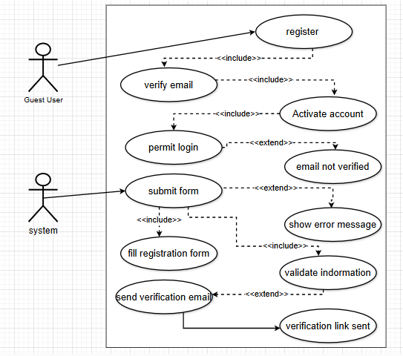

Figure 1: User registration

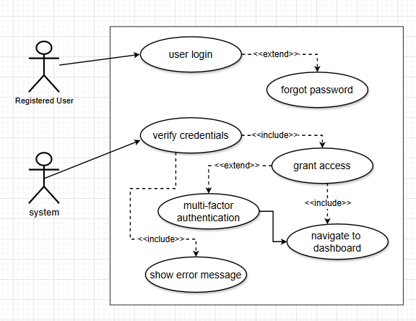

Figure 2: User Login and Authentication

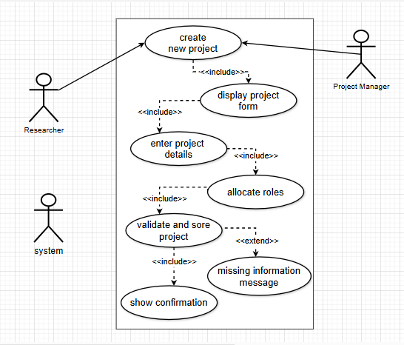

Figure 3: Create a Research Project

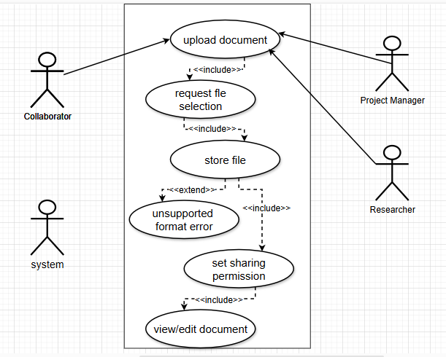

Figure 4: Upload and Share Documents

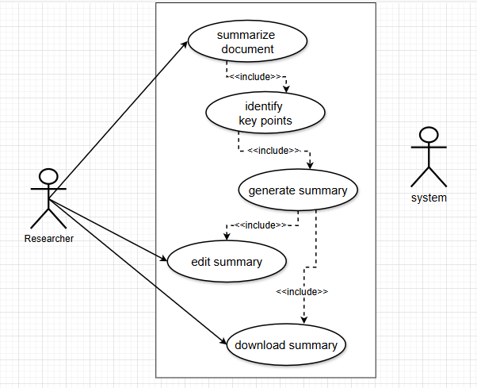

Figure 5: AI-Powered Research Paper Summarization

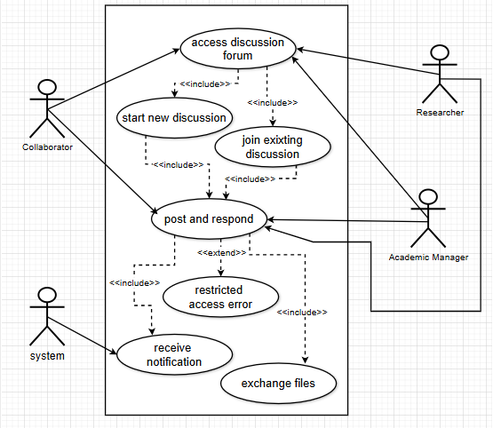

Figure 6: Join and Participate in Discussion Forums

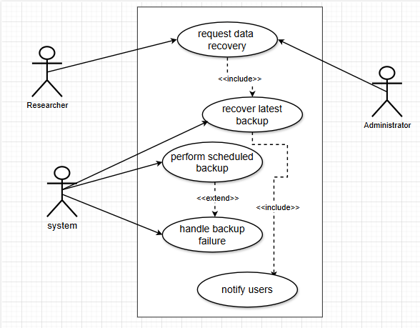

Figure 7: Secure Data Backup and Recovery

## Extended use cases

|  |  |  |  |  |
| --- | --- | --- | --- | --- |
| **Use Case ID:** | UC-1.1 | | | |
| **UseCase Name:** | User Registration | | | |
| **Created By:** | Fatima Ghaffar | | **Last Updated By:** | Kainat Munir |
| **Date Created:** | 20 december 2024 | | **Last Revision Date:** | 15 jan 2025 |
| **Actors:** | | **Primary:** Guest User  **Secondary:** System (Automated Platform) | | |
| **Description:** | | A user registers an account to access the platform. | | |
| **Trigger:** | | The guest user selects the "Register" option. | | |
| **Preconditions:** | | 1. The user has internet access. 2. The user has a valid email address. | | |
| **Post conditions:** | | 1. A new user account is successfully created. 2. The user receives a verification email. 3. The user can log in after verifying their email. | | |
| **Normal Flow:** | | 1. The guest user selects the "Register" option. 2. The system displays a registration form. 3. The user enters their name, email, password, affiliation, and role (e.g., researcher, academic manager). 4. The system verifies the entered details. 5. If valid, an email verification link is sent. 6. The user verifies the email by clicking the link. 7. The system activates the account and allows login. | | |
| **Alternative Flows:**  **[Alternative Flow 1 – Not in Network]** | | **AF-1: Invalid Email/Password**   * The system displays an error and prompts re-entry.   **AF-2: Email Not Verified**   * The user cannot log in until verification is completed. | | |
| **Exceptions:** | | **E-1: Email Already Exists**   * System notifies the user and suggests logging in instead.   **E-2: System Error**   * If an internal error occurs, a message is displayed, and the user is asked to try again later. | | |
| **Includes:** | | Email Verification Use Case | | |
| **Frequency of Use:** | | On-demand whenever a new user wants to register | | |
| **Special Requirements:** | | The system must use a secure password policy.  Email verification should be completed within 24 hours. | | |
| **Assumptions:** | | Users have access to their email inbox. | | |
| **Notes and Issues:** | | 1. Should we allow registration via third-party authentication (e.g., Google, Microsoft)? 2. Should we support multiple research roles per user? | | |

|  |  |  |  |  |
| --- | --- | --- | --- | --- |
| **Use Case ID:** | UC-1.2 | | | |
| **Use Case Name:** | User Login and Authentication | | | |
| **Created By:** | Fatima Ghaffar | | **Last Updated By:** | Kainat Munir |
| **Date Created:** | 20 december 2024 | | **Last Revision Date:** | 15 january 2025 |
| **Actors:** | | **Primary:** Registered User (Researcher, Academic Manager, Administrator)  **Secondary:** System | | |
| **Description:** | | A registered user logs into the system to access their account and perform research-related tasks. | | |
| **Trigger:** | | The user attempts to log into the platform by entering credentials. | | |
| **Preconditions:** | | 1. The user must have a registered account. 2. The user has internet access. 3. The user remembers their login credentials. | | |
| **Post conditions:** | | 1. The user is successfully logged in and gains access to the platform. 2. The system maintains an active session for the user. 3. The user can navigate to different features based on their role and permissions. | | |
| **Normal Flow:** | | 1. The user navigates to the login page. 2. The user enters their email and password. 3. The system validates the provided credentials. 4. If valid, the system grants access. 5. If Multi-Factor Authentication (MFA) is enabled, the system sends a one-time password (OTP) to the user's registered email. 6. The user enters the OTP for verification. 7. Upon successful verification, the system redirects the user to their dashboard. 8. The user can now interact with the system features based on their access level. | | |
| **Alternative Flows:**  **[Alternative Flow 1 – Not in Network]** | | **AF-1: Incorrect Credentials**   * The system displays an error message and prompts the user to re-enter their credentials. * If the user enters incorrect credentials multiple times, the system temporarily locks the account and notifies the user.   **AF-2: Forgot Password**   * The user selects the "Forgot Password" option. * The system prompts the user to enter their registered email. * A password reset link is sent to the user’s email. * The user resets the password and logs in successfully. | | |
| **Exceptions:** | | **E-1: Account Locked Due to Multiple Failed Attempts**   * If the user enters incorrect credentials more than the allowed attempts, the account is locked. * The user must wait for a cool down period or contact support to unlock the account.   **E-2: System Error**   * If the system encounters an unexpected error, an error message is displayed, and the user is prompted to try again later. | | |
| **Includes:** | | * Password Reset Use Case * Multi-Factor Authentication Use Case | | |
| **Frequency of Use:** | | Multiple times per day per user. | | |
| **Special Requirements:** | | * The system must support encryption of login credentials. * MFA must be configurable by the administrator. | | |
| **Assumptions:** | | Users have access to their registered email for verification. | | |
| **Notes and Issues:** | | 1. Should we allow biometric authentication in future versions? 2. Should the system provide login analytics to users for security insights? | | |

|  |  |  |  |  |
| --- | --- | --- | --- | --- |
| **Use Case ID:** | UC-1.3 | | | |
| **Use Case Name:** | Create a Research Project | | | |
| **Created By:** | Fatima Ghaffar | | **Last Updated By:** | Kainat Munir |
| **Date Created:** | 20 december 2024 | | **Last Revision Date:** | 15 january 2025 |
| **Actors:** | | **Primary:** Researcher, Project Manager  **Secondary:** System | | |
| **Description:** | | A researcher or project manager creates a new research project within the platform, assigning roles and defining project objectives. | | |
| **Trigger:** | | A registered user selects "Create New Project" from the dashboard. | | |
| **Preconditions:** | | 1. The user must be logged in. 2. The user has the necessary permissions to create projects. | | |
| **Post conditions:** | | 1. A new project is successfully created and visible to assigned members. 2. The project details are stored in the system. 3. Team members receive notifications about their assigned roles. | | |
| **Normal Flow:** | | 1. The user selects "Create New Project" from the dashboard. 2. The system displays a project creation form. 3. The user enters the required details, including:    * Project name    * Objectives    * Timeline    * Team members    * Assigned roles (e.g., researcher, collaborator) 4. The system validates and saves the project details. 5. The system sends notifications to assigned team members. 6. The project appears in the dashboard, accessible to authorized users. | | |
| **Alternative Flows:**  **[Alternative Flow 1 – Not in Network]** | | **AF-1: Missing Required Fields**   * If the user does not enter all required fields, the system prompts them to complete the missing information. | | |
| **Exceptions:** | | **E-1: System Error**   * If an error occurs while saving the project, the system displays an error message and logs the issue. | | |
| **Includes:** | | Assign Team Members Use Case  Project Timeline Management Use Case | | |
| **Frequency of Use:** | | On-demand when new research projects are initiated. | | |
| **Special Requirements:** | | The system must ensure secure storage of project details.  Role-based access control should be implemented to manage project permissions. | | |
| **Assumptions:** | | * Users know their project details before creating it. * The system has enough storage to accommodate new projects. | | |
| **Notes and Issues:** | | 1. Should project deadlines be strictly enforced? 2. Should there be an approval process before the project is officially created? | | |

|  |  |  |  |  |
| --- | --- | --- | --- | --- |
| **Use Case ID:** | UC-1.4 | | | |
| **Use Case Name:** | Upload and Share Research Documents | | | |
| **Created By:** | Fatima Ghaffar | | **Last Updated By:** | Kainat Munir |
| **Date Created:** | 20 december 2024 | | **Last Revision Date:** | 15 january 2025 |
| **Actors:** | | **Primary:** Researcher, Collaborator, Project Manager  **Secondary:** System | | |
| **Description:** | | Users upload and share research documents within a project, ensuring controlled access and collaboration. | | |
| **Trigger:** | | A registered user selects "Upload Document" within an active research project. | | |
| **Preconditions:** | | 1. The user must be logged in. 2. The user must have access to at least one research project. 3. The system must support the selected file format. | | |
| **Post conditions:** | | 1. The document is successfully uploaded and stored securely. 2. Authorized users can access, edit, or comment on the document based on assigned permissions. 3. The system maintains a version history of the document. | | |
| **Normal Flow:** | | 1. The user selects "Upload Document" within a project. 2. The system prompts the user to select a file. 3. The user uploads a document (PDF, DOCX, etc.). 4. The system verifies the file format and size. 5. If valid, the system securely stores the document. 6. The user sets sharing permissions (view, edit, comment) for collaborators. 7. The system notifies authorized users about the newly uploaded document. 8. Authorized users can access and collaborate on the document. | | |
| **Alternative Flows:**  **[Alternative Flow 1 – Not in Network]** | | **AF-1: Unsupported File Format**   * If the user uploads an unsupported file type, the system displays an error message and provides a list of supported formats.   **AF-2: Large File Upload**   * If the file exceeds the allowed size limit, the system notifies the user and suggests compressing or splitting the file. | | |
| **Exceptions:** | | **E-1: System Error During Upload**   * If the system encounters an error while uploading, it displays an error message and prompts the user to retry. | | |
| **Includes:** | | * Document Version Control Use Case * Permission Management Use Case | | |
| **Frequency of Use:** | | Frequently used whenever researchers need to upload or share documents. | | |
| **Special Requirements:** | | * The system must provide secure storage and encryption for research documents. * Role-based access control should be implemented for document sharing. * The system should support collaborative editing with version tracking. | | |
| **Assumptions:** | | * Users are aware of the supported file formats. * Users correctly assign sharing permissions. | | |
| **Notes and Issues:** | | 1. Should the system allow integration with cloud storage services like Google Drive or Dropbox? 2. Should the system support automatic file conversion for unsupported formats? | | |

|  |  |  |  |  |
| --- | --- | --- | --- | --- |
| **Use Case ID:** | UC-1.5 | | | |
| **Use Case Name:** | AI-Powered Research Paper Summarization | | | |
| **Created By:** | Fatima Ghaffar | | **Last Updated By:** | Kainat Munir |
| **Date Created:** | 20 december 2024 | | **Last Revision Date:** | 15 january 2025 |
| **Actors:** | | **Primary:** Researcher  **Secondary:** System | | |
| **Description:** | | The system automatically summarizes research papers uploaded by users, extracting key points for quick reference and review. | | |
| **Trigger:** | | A registered user selects "Summarize Document" after uploading a research paper. | | |
| **Preconditions:** | | 1. The user must be logged in. 2. The user must have uploaded a valid research document. 3. The system must support the document format (e.g., PDF, DOCX). | | |
| **Post conditions:** | | 1. A summarized version of the research paper is available. 2. The user can edit, save, or download the summary. 3. The system may provide additional insights based on the extracted data. | | |
| **Normal Flow:** | | 1. The user selects "Summarize Document" from the document menu. 2. The system scans and processes the uploaded document. 3. The system extracts:    * Key points    * Abstract    * Conclusions 4. The system generates a structured summary. 5. The summarized document is displayed to the user. 6. The user can review, edit, and download the summary. | | |
| **Alternative Flows:**  **[Alternative Flow 1 – Not in Network]** | | **AF-1: Unsupported Document Format**   * If the document format is not supported, the system notifies the user and suggests converting the file to a supported format.   **AF-2: Poor Text Recognition**   * If the system encounters issues extracting text (e.g., due to poor scan quality), it notifies the user and suggests uploading a clearer version. | | |
| **Exceptions:** | | **E-1: System Error During Summarization**   * If the system encounters an error, it logs the issue and prompts the user to retry later. | | |
| **Includes:** | | * Document Processing Use Case * AI Text Extraction Use Case | | |
| **Frequency of Use:** | | On-demand whenever researchers need to summarize research papers. | | |
| **Special Requirements:** | | * The system should use AI-driven Natural Language Processing (NLP) techniques. * Summarization should maintain the accuracy and context of the research paper. * The system should provide an option to refine or regenerate summaries. | | |
| **Assumptions:** | | * Users upload research papers in a readable format. * AI algorithms are capable of accurately extracting research information. | | |
| **Notes and Issues:** | | 1. Should the system allow users to request detailed summaries with specific sections? 2. Should the system provide citation analysis along with the summary? | | |

|  |  |  |  |  |
| --- | --- | --- | --- | --- |
| **Use Case ID:** | UC-1.6 | | | |
| **Use Case Name:** | Join and Participate in Discussion Forums | | | |
| **Created By:** | Fatima Ghaffar | | **Last Updated By:** | Kainat Munir |
| **Date Created:** | 20 december 2024 | | **Last Revision Date:** | 15 january 2025 |
| **Actors:** | | **Primary:** Researcher, Collaborator, Academic Manager  **Secondary:** System | | |
| **Description:** | | Users create and engage in research-related discussions within the platform’s discussion forums, allowing collaboration and knowledge sharing. | | |
| **Trigger:** | | A registered user accesses the discussion forum section. | | |
| **Preconditions:** | | 1. The user must be logged in. 2. The user must have the required permissions to post or reply. 3. The discussion forum must be active and accessible. | | |
| **Post conditions:** | | 1. New discussion topics and responses are stored and accessible to research teams. 2. Participants receive notifications about updates. 3. The system maintains an archive of discussions for future reference. | | |
| **Normal Flow:** | | 1. The user navigates to the "Discussion Forum" section. 2. The user selects either "Create New Topic" or "Join Existing Discussion". 3. If creating a new topic:    * The user enters a title, description, and optional tags.    * The system verifies input and publishes the topic.    * Other users can now join the discussion. 4. If joining an existing discussion:    * The user selects a topic.    * They can post messages, reply, or share files.    * The system notifies other participants of the new activity. 5. The system stores all discussion threads and replies. 6. Users can search, filter, and retrieve past discussions. | | |
| **Alternative Flows:**  **[Alternative Flow 1 – Not in Network]** | | **AF-1: Restricted Access**   * If the user lacks permission, the system displays an error message. * The user can request access from the forum administrator.   **AF-2: Discussion Closed**   * If the discussion is archived or locked, the user can view but not post new messages. | | |
| **Exceptions:** | | **E-1: System Error While Posting**   * If the system fails to store a message, it logs the error and notifies the user. | | |
| **Includes:** | | * Notification Management Use Case * File Sharing in Discussion Use Case | | |
| **Frequency of Use:** | | Frequently used by researchers for discussions on active projects. | | |
| **Special Requirements:** | | * The system must support multimedia attachments (PDFs, images, links). * A moderation feature should be available to prevent spam or irrelevant posts. * Users should be able to subscribe to discussions for real-time updates. | | |
| **Assumptions:** | | * Users will adhere to platform discussion guidelines. * The system will maintain discussion history for future reference. | | |
| **Notes and Issues:** | | 1. Should users be able to create private discussions within research groups? 2. Should AI moderation be implemented to flag inappropriate content? | | |

|  |  |  |  |  |
| --- | --- | --- | --- | --- |
| **Use Case ID:** | UC-1.7 | | | |
| **Use Case Name:** | Secure Data Backup and Recovery | | | |
| **Created By:** | Fatima Ghaffar | | **Last Updated By:** | Kainat Munir |
| **Date Created:** | 20 december 2024 | | **Last Revision Date:** | 15 january 2025 |
| **Actors:** | | **Primary:** System  **Secondary:** Researcher, Administrator | | |
| **Description:** | | The system automatically backs up research data at scheduled intervals and allows recovery in case of accidental deletion, corruption, or system failure. | | |
| **Trigger:** | | * The system performs an automatic scheduled backup. * A user (Researcher or Administrator) requests data recovery. | | |
| **Preconditions:** | | 1. The system must have scheduled backup mechanisms enabled. 2. The user must have permission to request data recovery. 3. Backup storage must have sufficient capacity. | | |
| **Post conditions:** | | 1. Data is backed up securely and is available for restoration. 2. In case of data loss, the latest backup version is successfully restored. 3. Users receive confirmation of a successful data restoration. | | |
| **Normal Flow:** | | 1. The system automatically initiates scheduled backups of research documents and datasets. 2. The backup process:    * Identifies new or modified files.    * Compresses and encrypts data for secure storage.    * Saves backup files to a designated secure storage location. 3. In case of data loss or corruption, the Administrator or Researcher initiates a recovery request. 4. The system verifies the request and presents available backup versions. 5. The user selects the desired backup version. 6. The system restores the selected data. 7. The user receives a confirmation of successful restoration. | | |
| **Alternative Flows:**  **[Alternative Flow 1 – Not in Network]** | | **AF-1: Backup Failure**   * If the backup process fails, the system logs an error and retries in the next scheduled cycle.   The Administrator receives a failure notification and can manually trigger a backup.  **AF-2: No Backup Available**   * If no backup version is found, the system notifies the user and suggests alternative data recovery options. | | |
| **Exceptions:** | | **E-1: System Error During Restoration**   * If an error occurs while restoring data, the system logs the issue and prompts the user to retry later or contact support. | | |
| **Includes:** | | * Data Encryption and Storage Use Case * User Access Control for Backup and Recovery Use Case | | |
| **Frequency of Use:** | | * Automatically triggered based on scheduled backup intervals. * On-demand when users request data recovery. | | |
| **Special Requirements:** | | * Backups must be encrypted and stored in a secure environment. * The system should support multiple backup versions to allow flexible recovery. * Users should receive notifications for successful or failed backup operations. | | |
| **Assumptions:** | | * Users rely on the system’s automated backup process without needing manual intervention. * The system has sufficient resources to handle frequent backups and restores. | | |
| **Notes and Issues:** | | 1. Should users be allowed to customize backup frequency and retention periods? 2. Should an AI-driven anomaly detection feature be implemented to identify potential data corruption before backup? | | |

## User interfaces (mock screens)



Figure 8: Screen 1

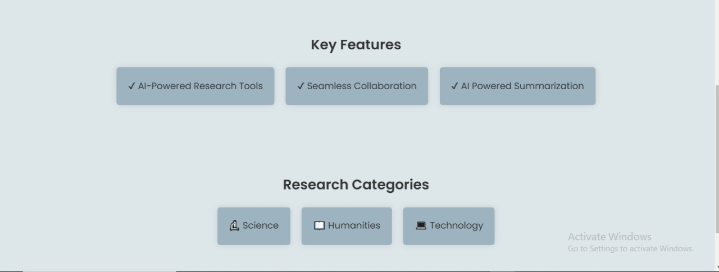

Figure 9: Screen 2

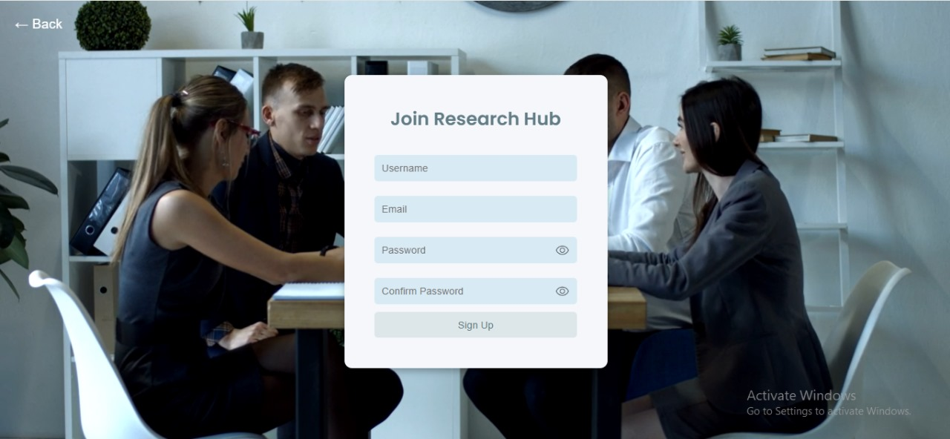

Figure 10: Screen 3

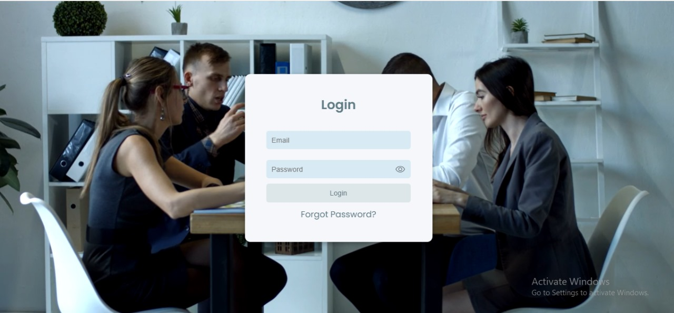

Figure 11: Screen 4

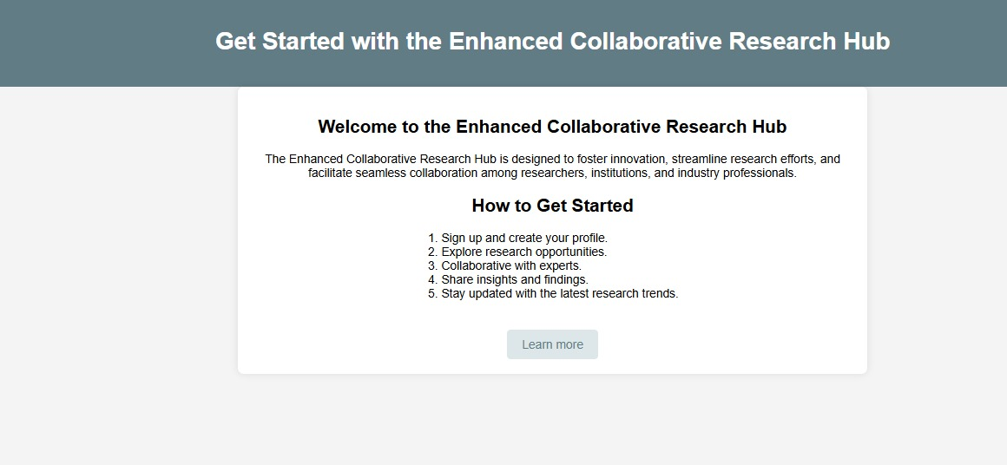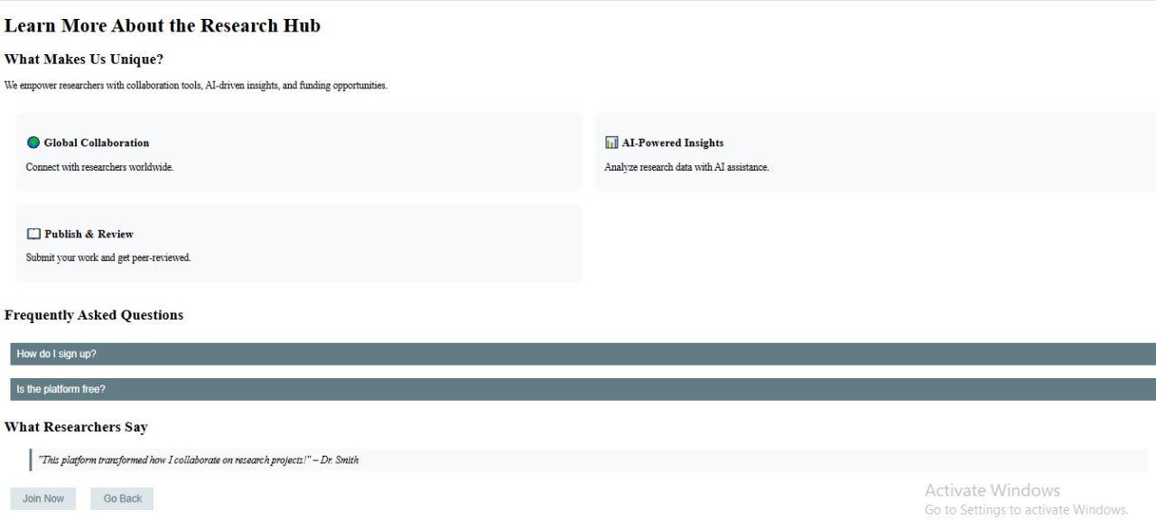

Figure 12: Screen 5

Figure 13: Screen 6

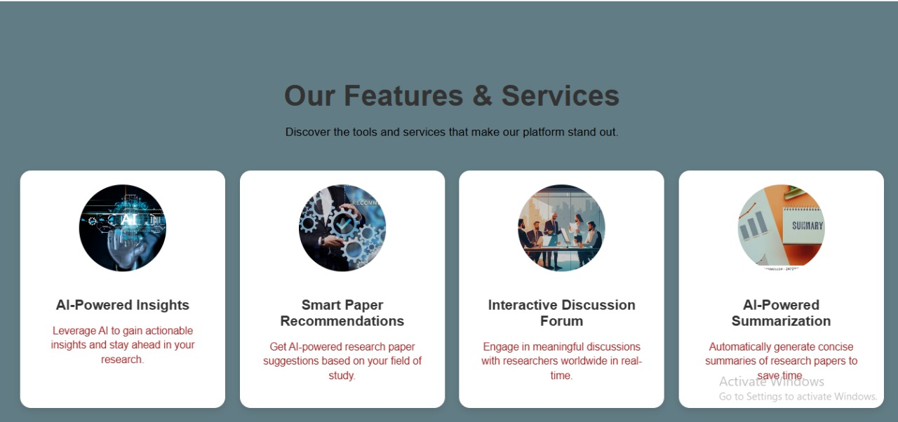

Figure 14: Screen 7

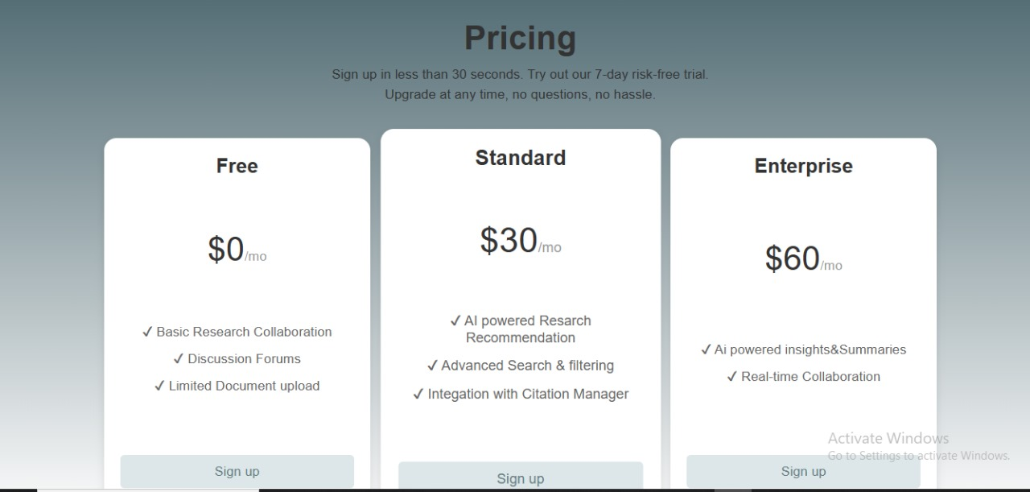

Figure 15: Screen 8

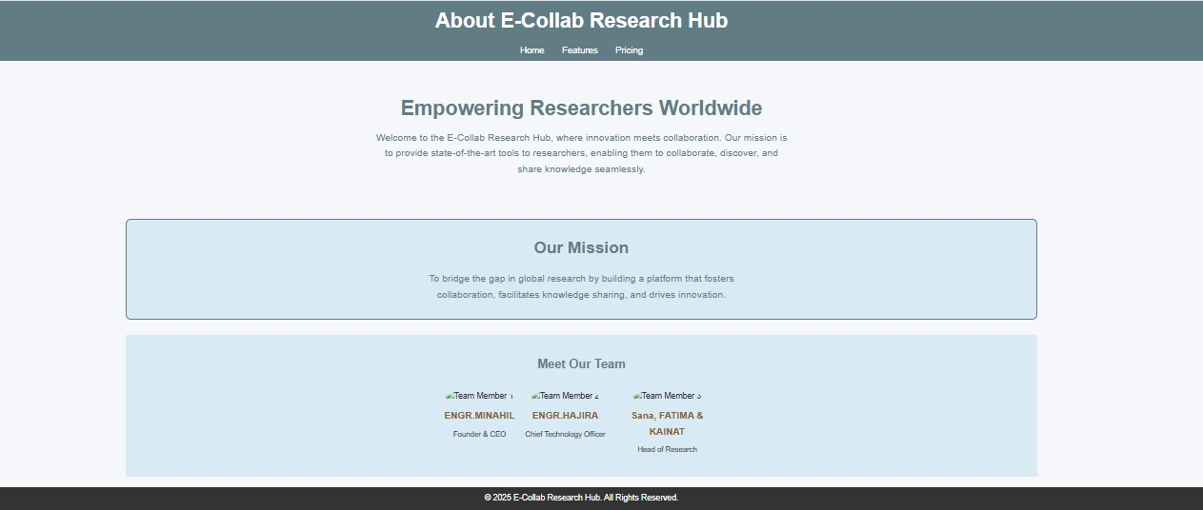

Figure 16: Screen 9

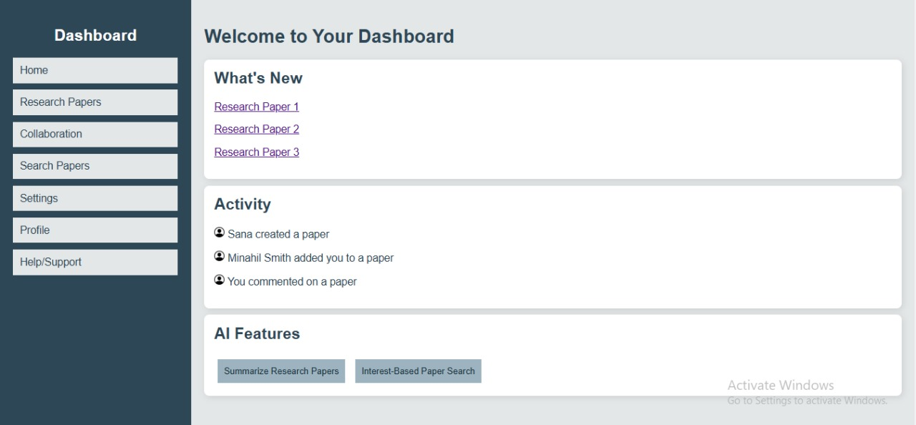

Figure 17: Screen 10

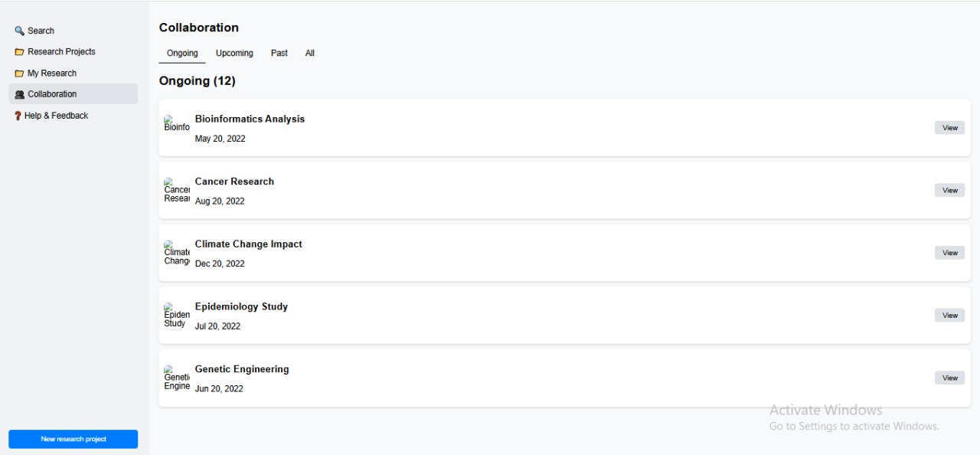

Figure 18: Screen 11

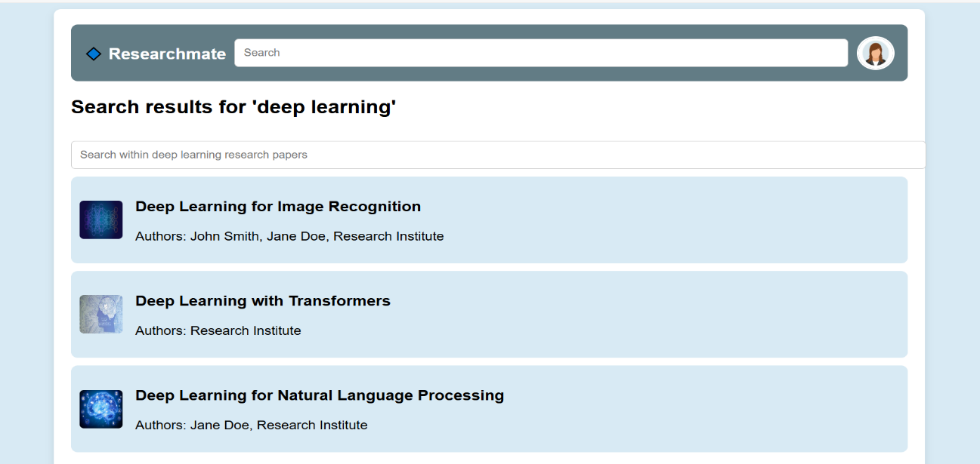

Figure 19: Screen 12

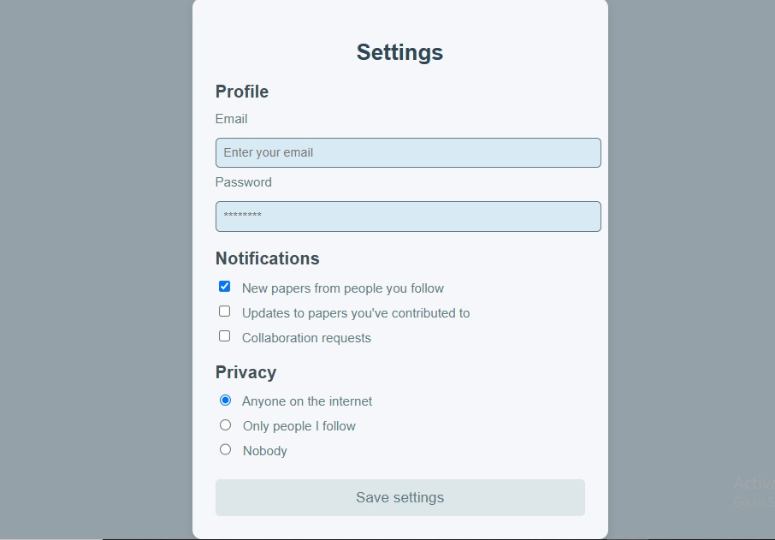

Figure 20: Screen 13

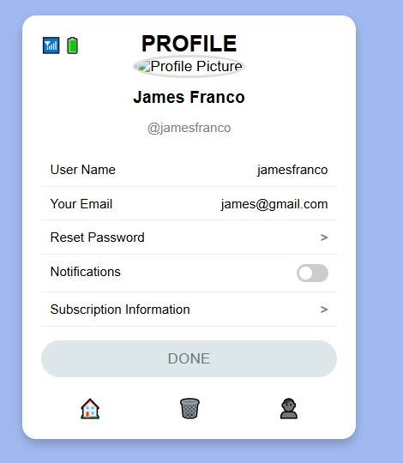

Figure 21: Screen 14

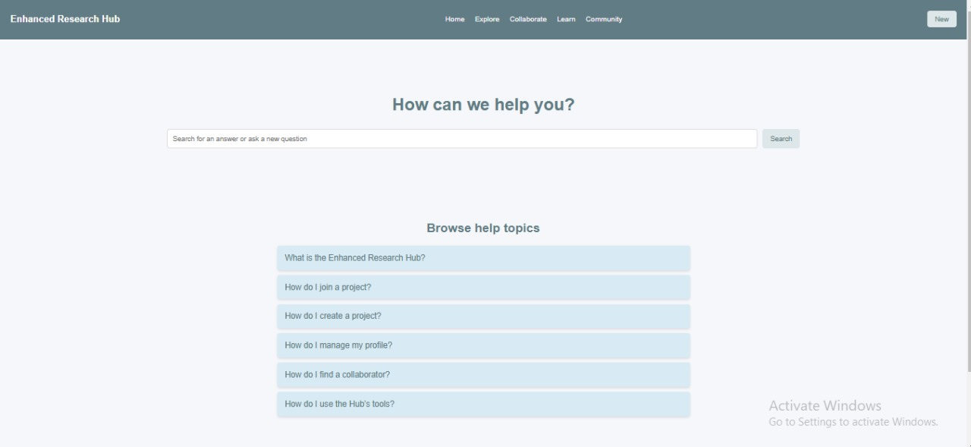

Figure 22: Screen 15

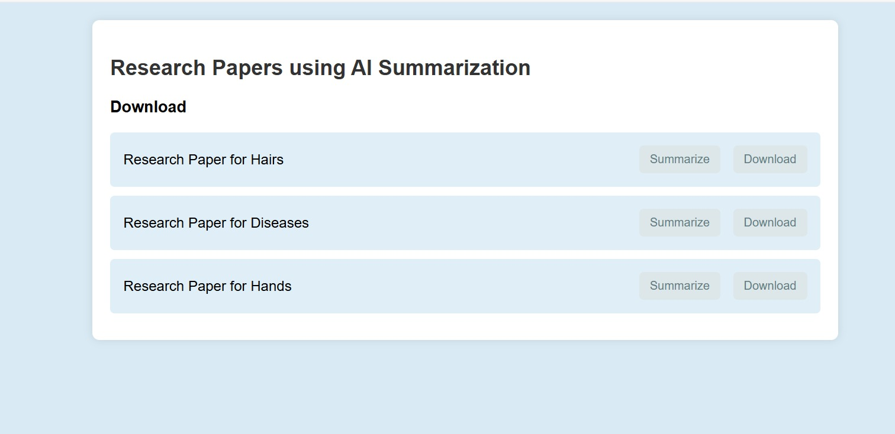

Figure 23: Screen 16

# Data Flow Diagram

## Data Flow Diagram Level 0

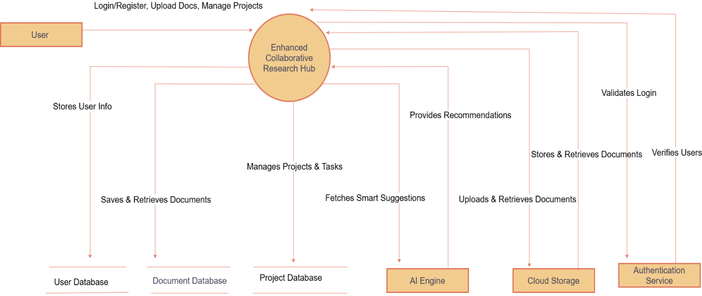

Figure 24: Data flow level 0

## Data Flow Diagram Level 1

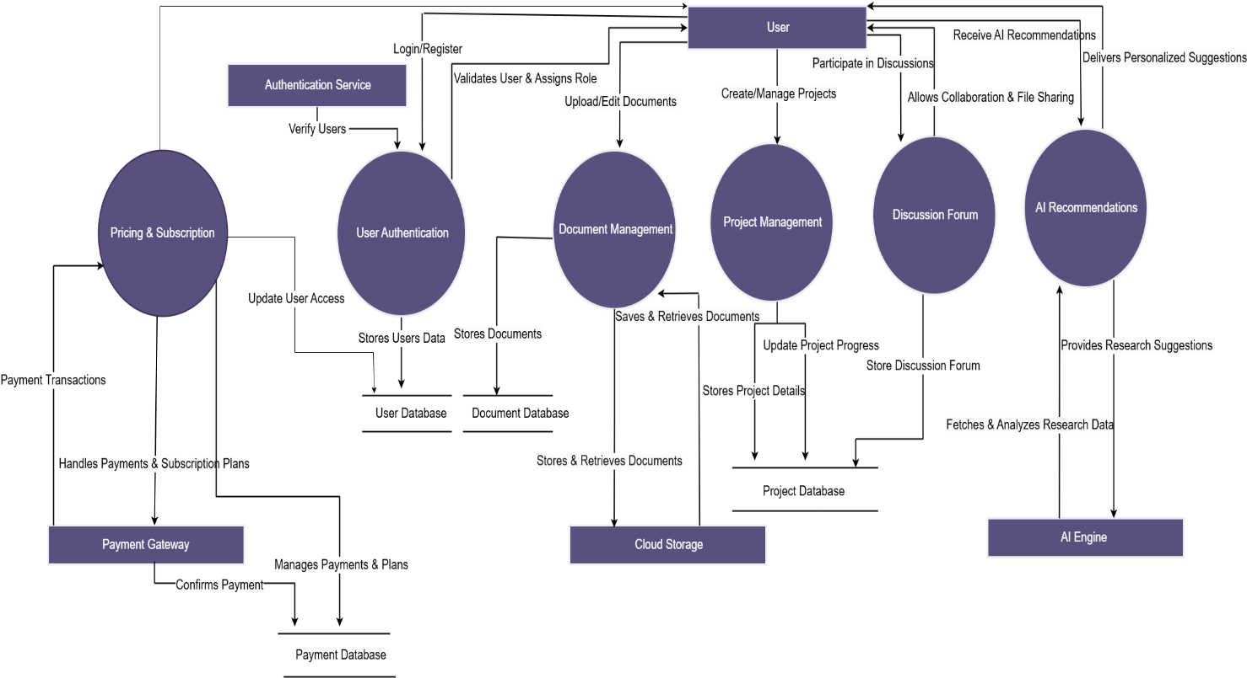

Figure 25: Data flow level 1

## Data Flow Diagram Level 2

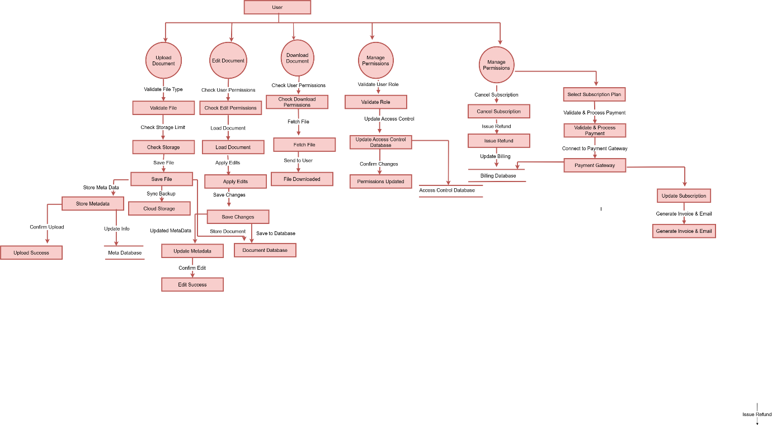

Figure 26: Data flow level 2

# SYSTEM DESIGN

## System Architecture Diagram

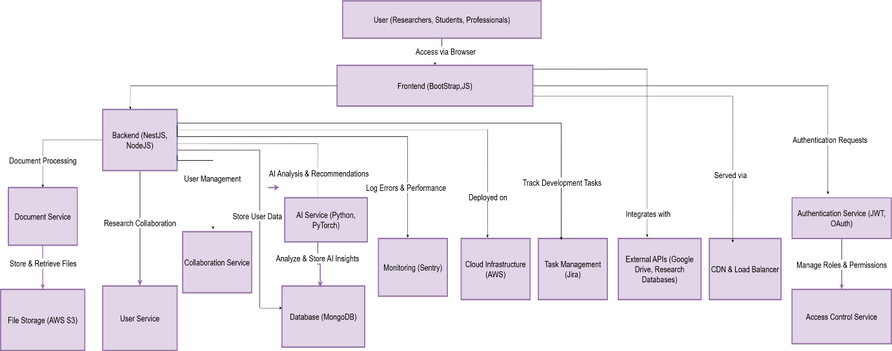

Figure 27: System architecture

## Class Diagram

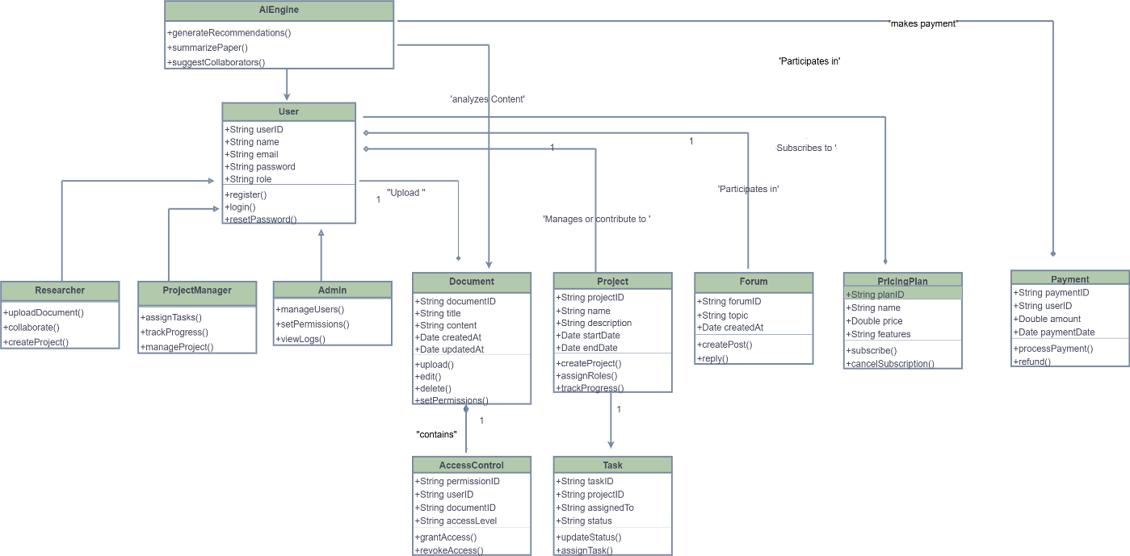

Figure 28: Class Diagram

## Sequence Diagram

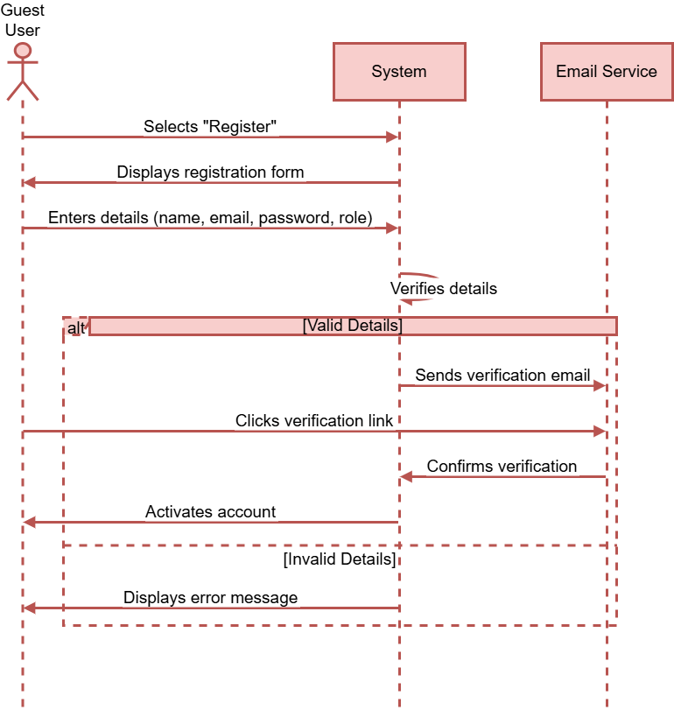

Figure 29: User Registration (with Actor)

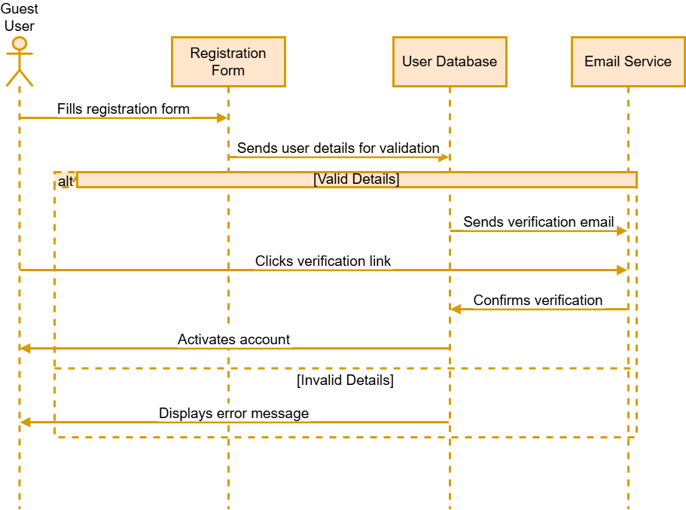

Figure 30: User Login and Authentication

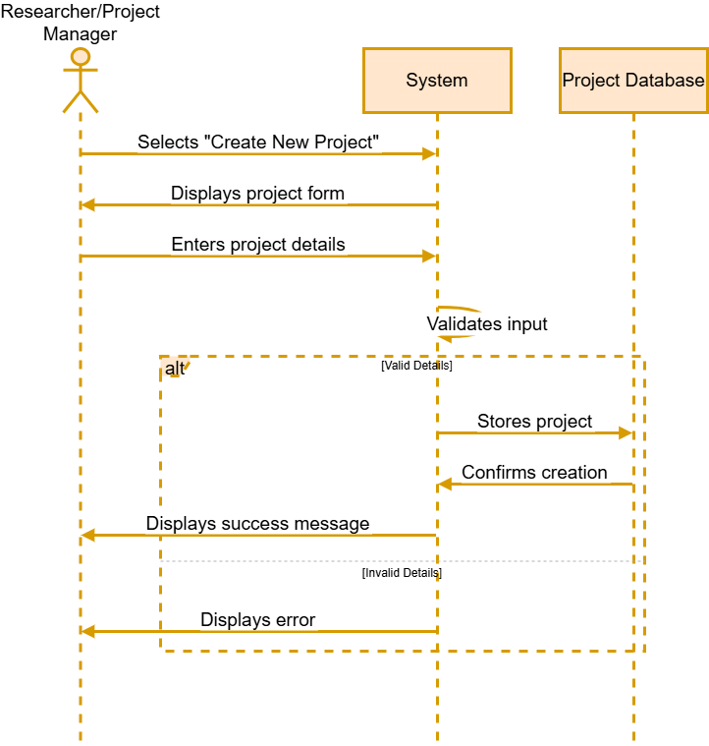

Figure 31: Creating a Research Project

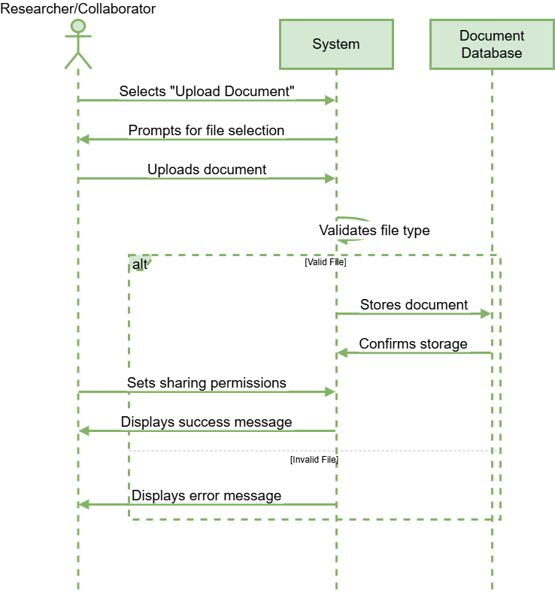

Figure 32: Uploading and Sharing Research Documents

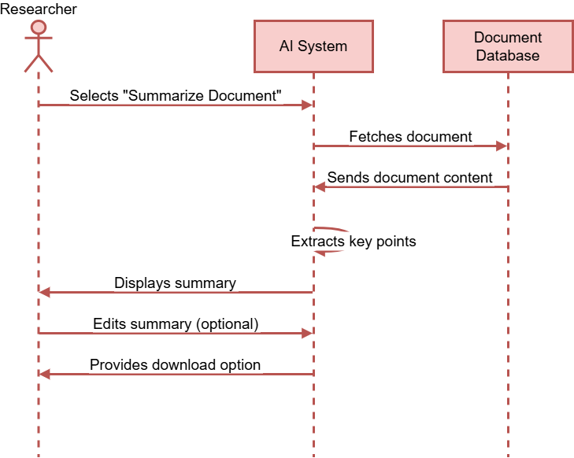

Figure 33: AI-Powered Research Paper Summarization

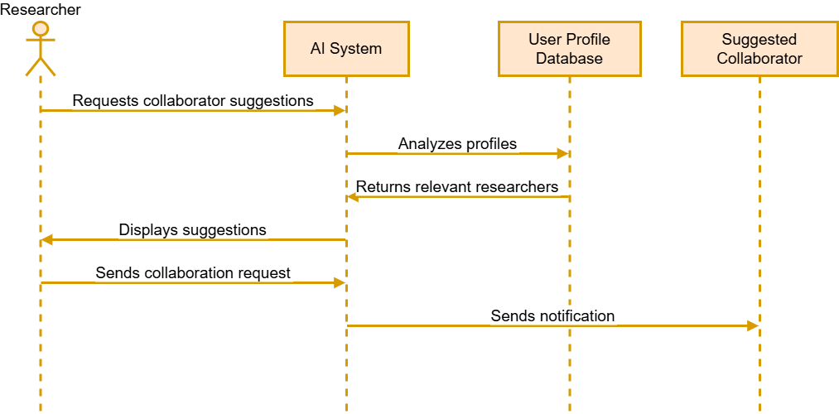

Figure 34: AI-Powered Collaborator Matching

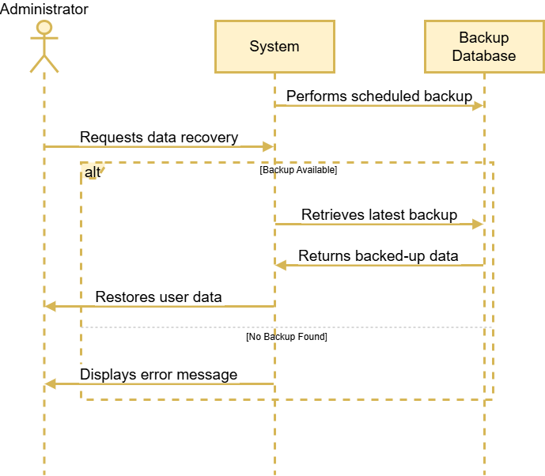

Figure 35: Secure Data Backup and Recovery

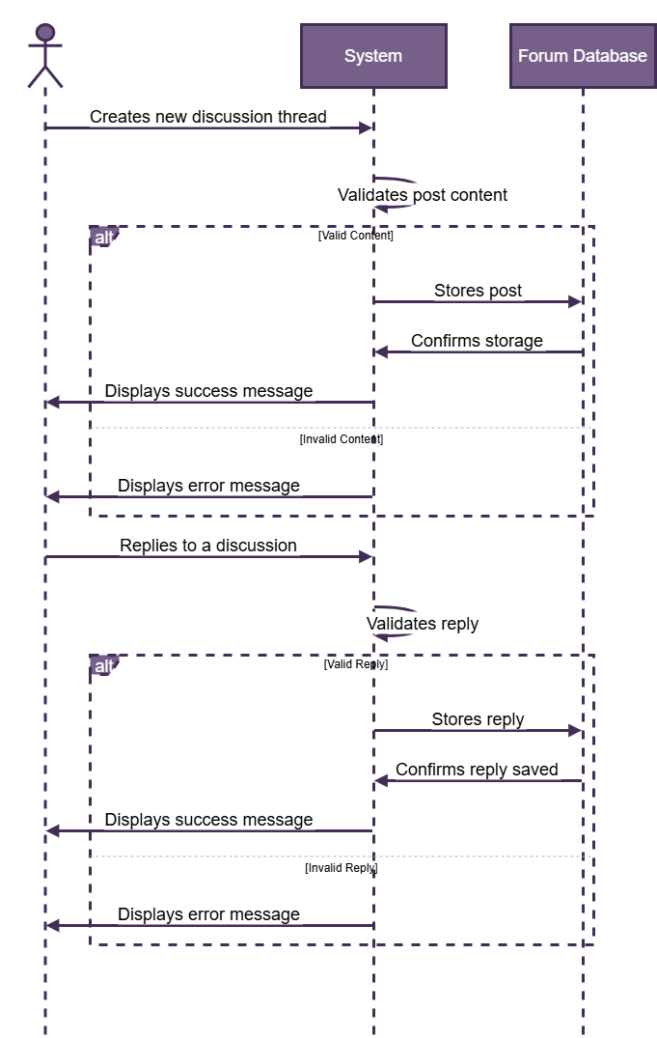

Figure 36: Research Discussion Forum (Post & Reply)

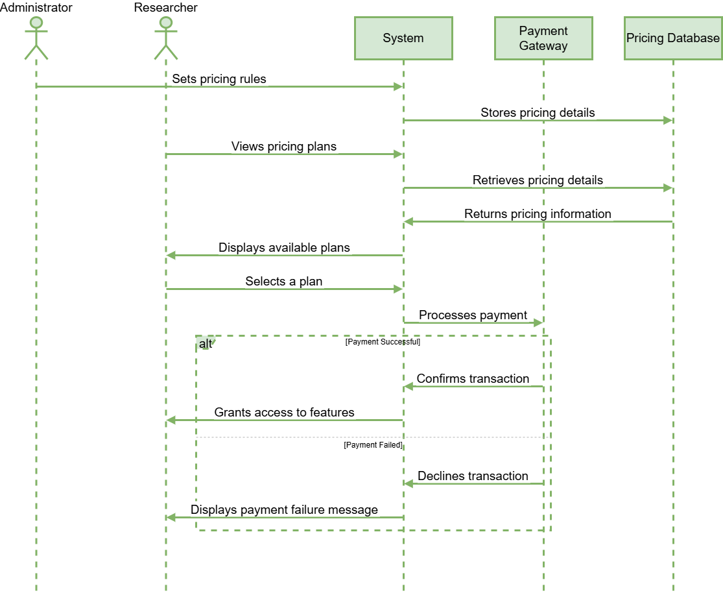

Figure 37: Pricing Management

## Object Sequence Diagram

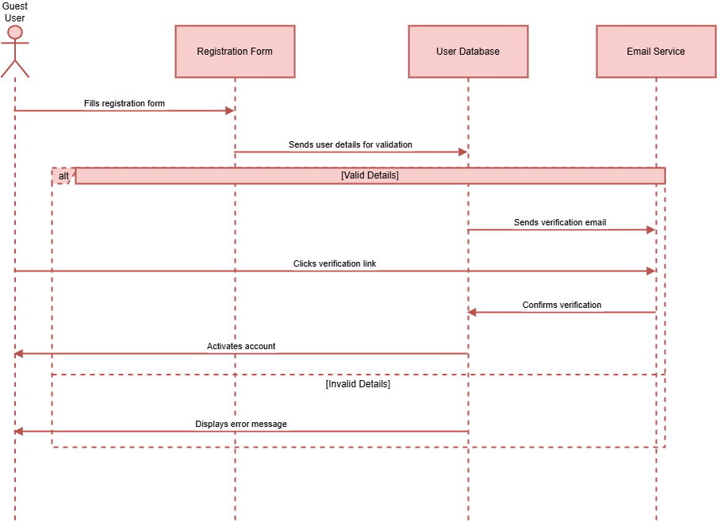

Figure 38: User Registration (with Actor)

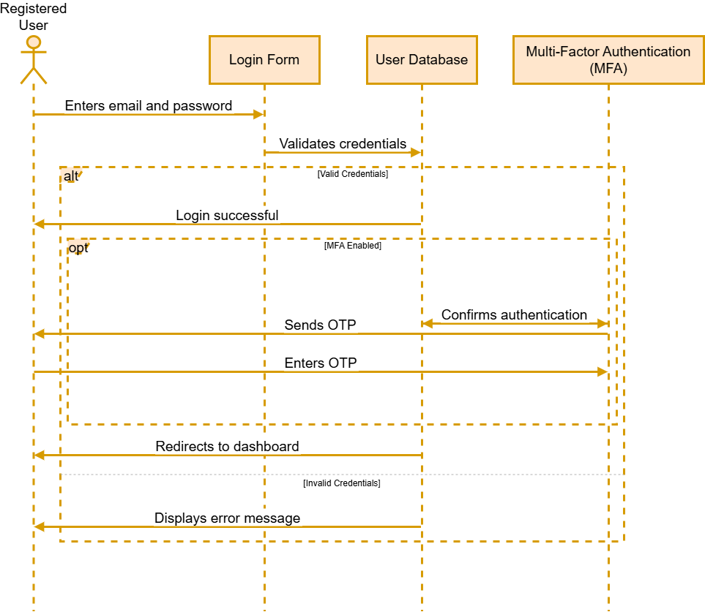

Figure 39: User Login and Authentication

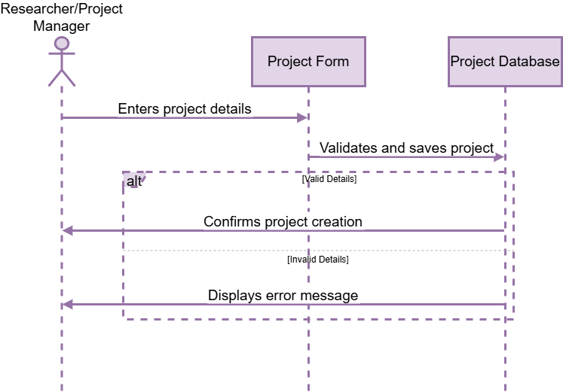

Figure 40: Creating a Research Project

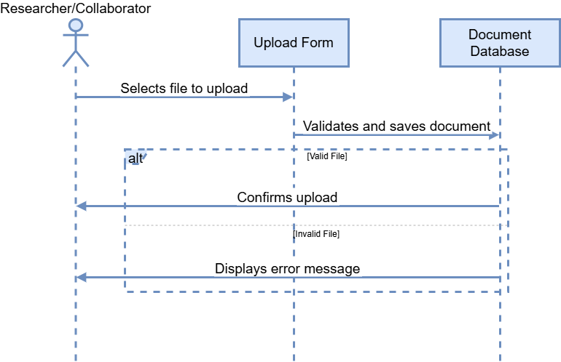

Figure 41: Uploading and Sharing Research Documents

Figure 42: AI-Powered Collaborator Matching

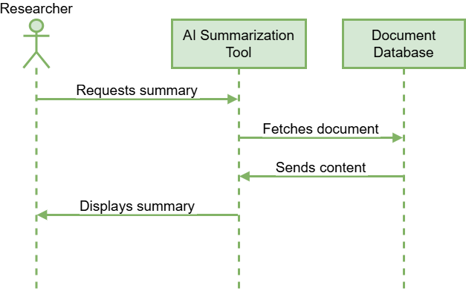

Figure 43: AI-Powered Research Paper Summarization

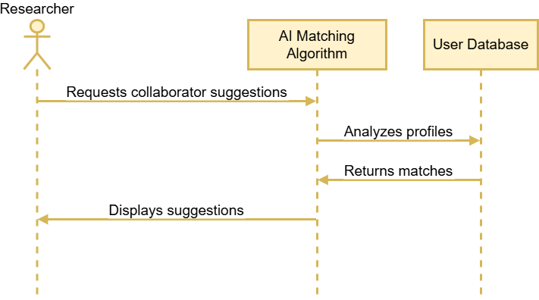

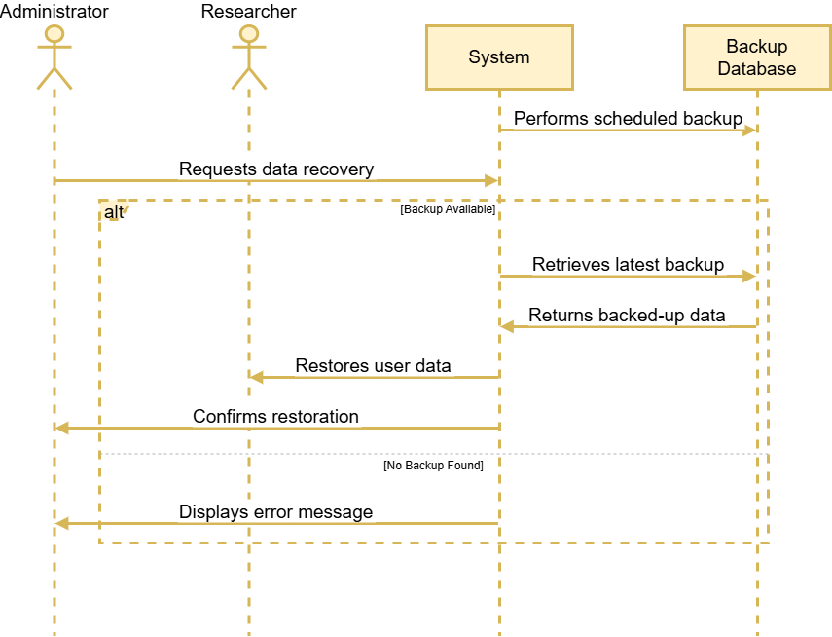

Figure 44: Secure Data Backup and Recovery

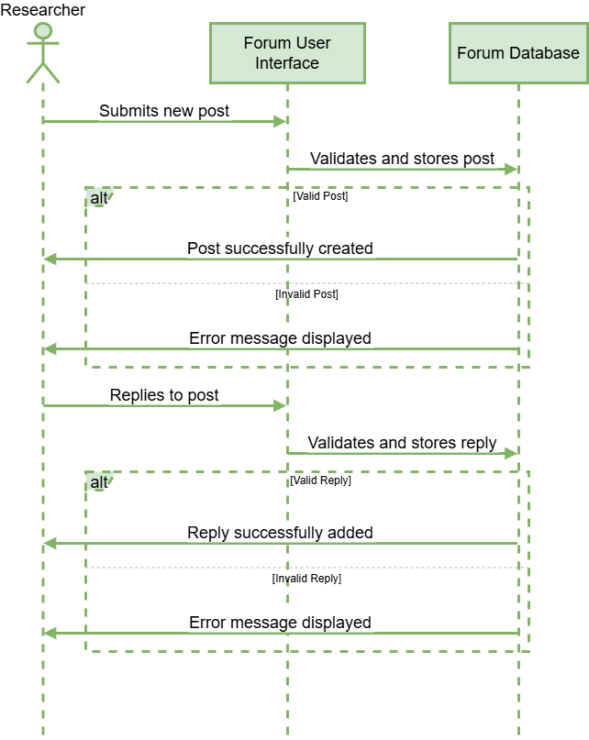

Figure 45: Research Discussion Forum (Post & Reply)

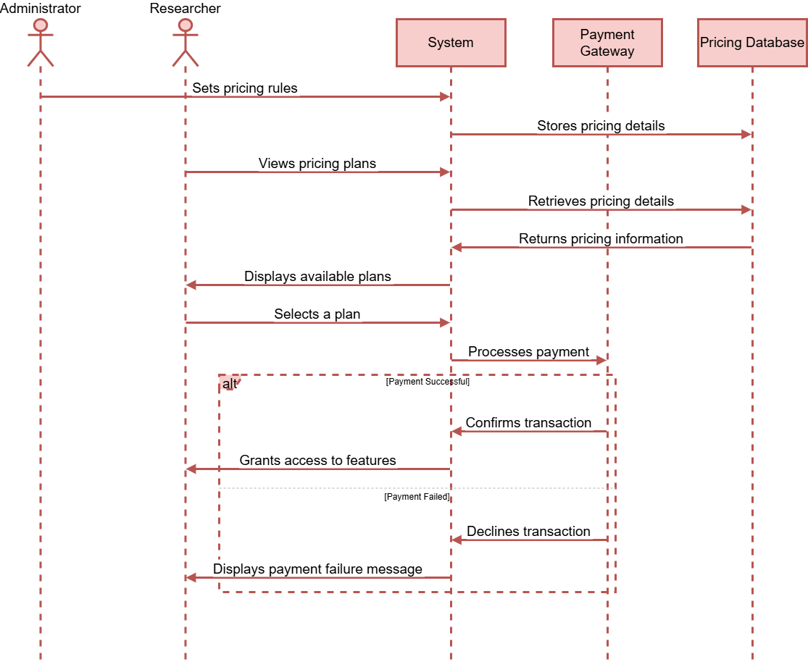

Figure 46: Pricing Management

## ERD

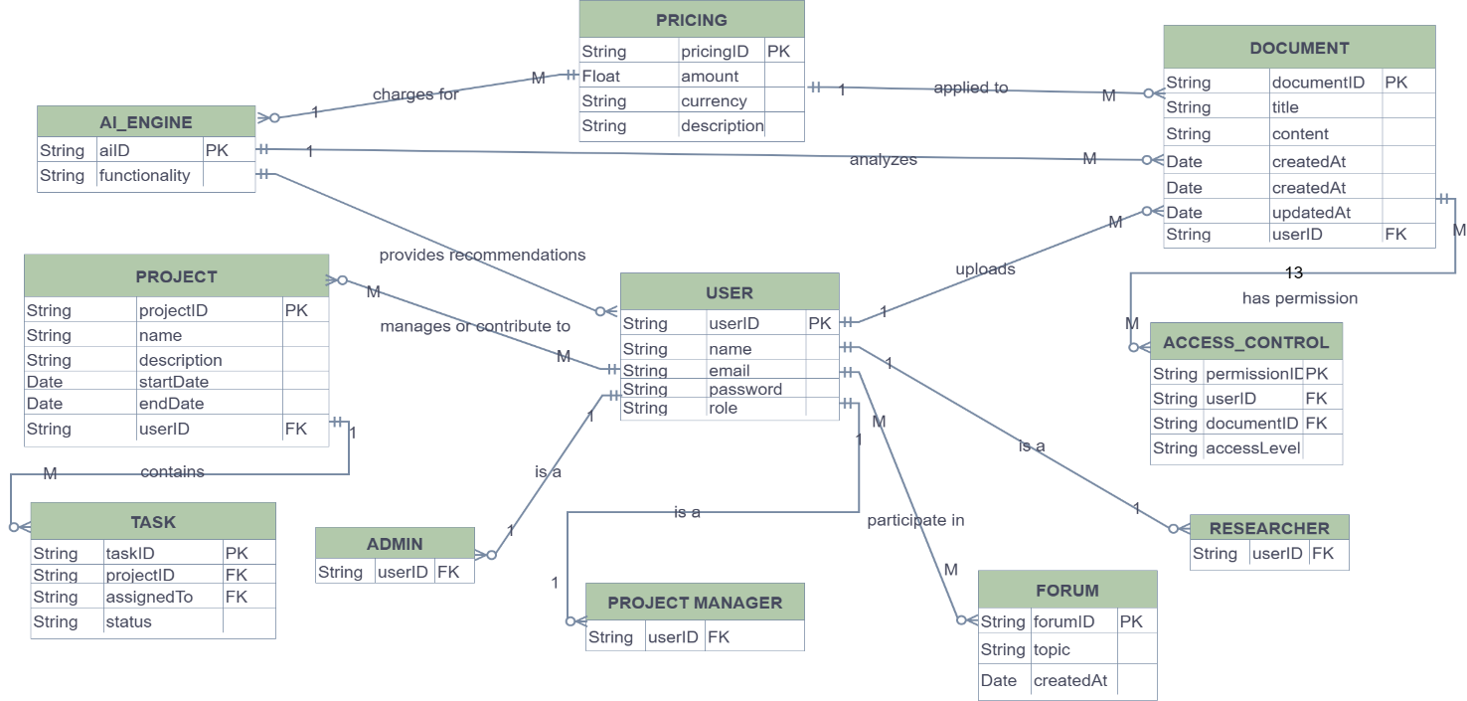

Notation follow by: Korth & Silberschatz

Figure 47: ERD Diagram

## State Design

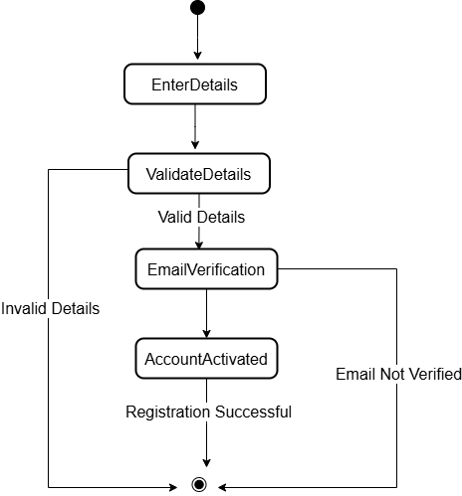

Figure 48: User Registration

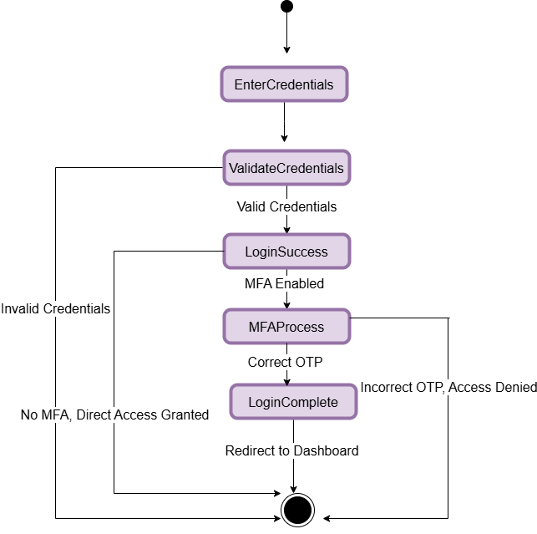

Figure 49: User Login & Authentication

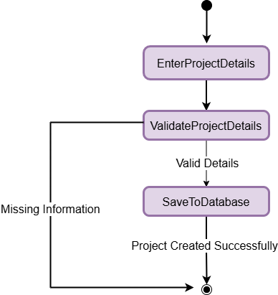

Figure 50: Research Project Creation

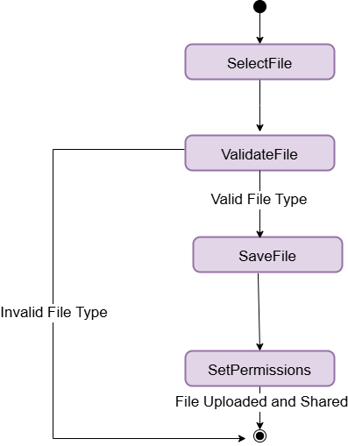

Figure 51: Uploading & Sharing Research Documents

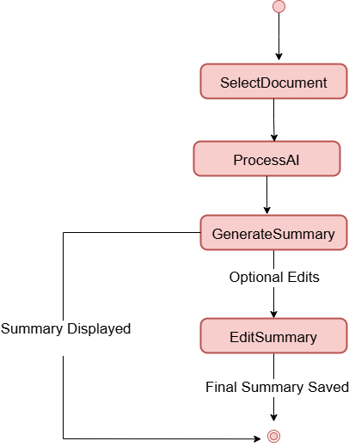

Figure 52: AI-Powered Research Paper Summarization

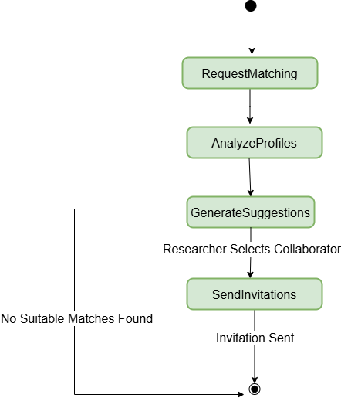

Figure 53: AI-Powered Collaborator Matching

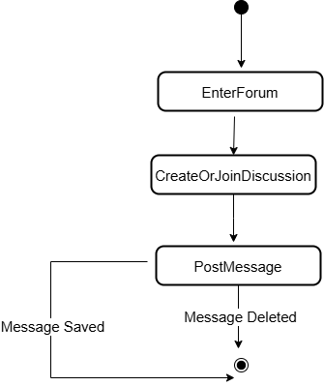

Figure 54: Joining & Participating in Discussion Forums

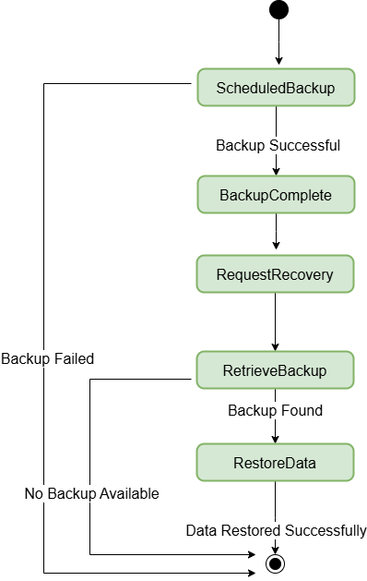

Figure 55: Secure Data Backup & Recovery

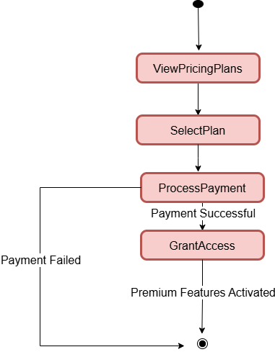

Figure 56: Pricing Management

## Activity Diagram

## 

Figure 57: Activity Diagram

## Polymorphism Diagram

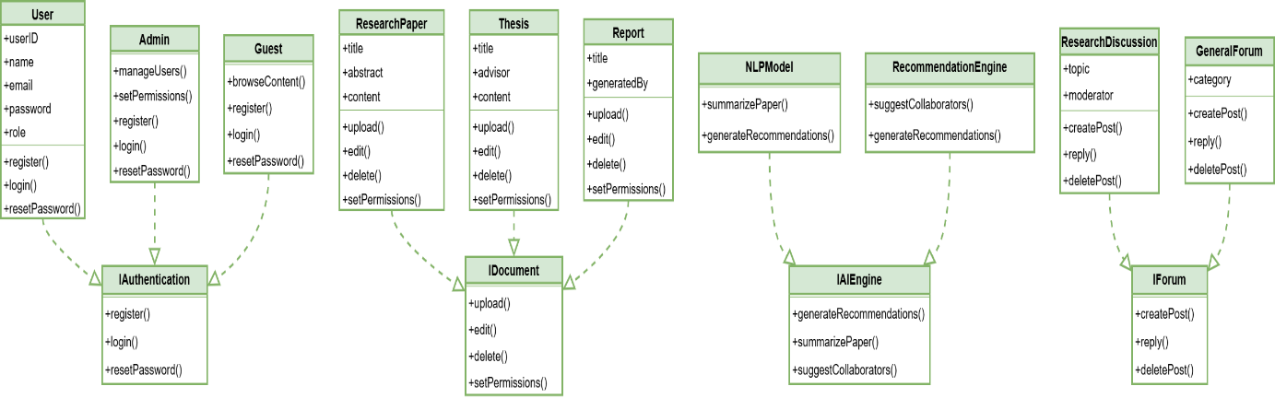

Figure 58: Polymorphism Diagram

## Realization Diagram

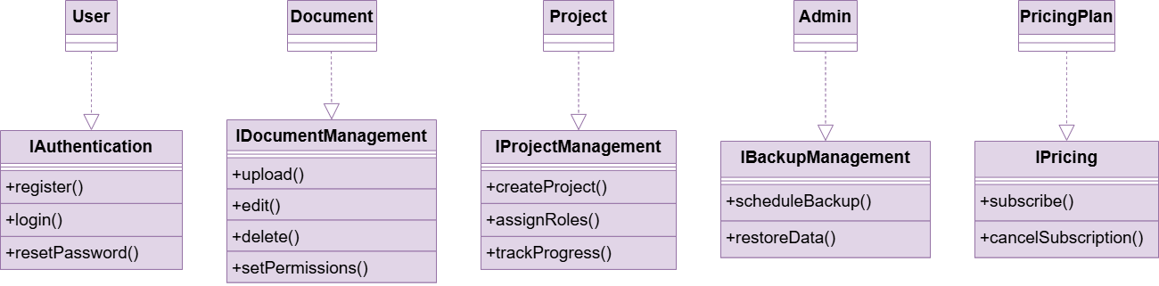

Figure 59: Realization Diagram

# IMPLEMENTATION

## SCREEN N0 1:



This is the Landing Page of the Advanced Research Hub, intended to present users to the platform.

Key Features:

* 1. **Top Navigation Bar:**
* Features: Emphasizes the abilities of the platform.
* Categories: Indicates varying research fields.
* Pricing: Exhibits subscription or service fees.
* About: Gives information regarding the platform.
* Sign Up / Log In Buttons: Enables users to sign up for an account or log in to an account.
  1. **Hero Section:**
* Background Video/Image: Includes a collaborative research environment.
* Tagline: "Uniting researchers with cutting-edge tools and AI-powered insights."
* Call-to-Action (CTA) Buttons:
* Get Started: Probably links to sign-up or onboarding.
* Explore More: Gives more information regarding the platform.

.

## SCREEN N0 2:

### 

Functionality of Clickable Elements on This Page

This page points to major features and research categories of a platform, probably of AI-based research tools.

1. **Key Features Section:**

* AI-Powered Research Tools → Probably directs to a page describing AI tools for research.
* Seamless Collaboration → Might direct to a collaboration dashboard or feature description.
* AI-Powered Summarization → Probably directs to a summarization tool for research papers.

1. **Research Categories Section:**
   * Science → Takes to science-related research papers or resources.
   * Humanities → Takes to humanities research material.
   * Tech → Takes to technology-oriented research papers or resources.

Each button likely loads a new page or section for each category.

## SCREEN N0 3:



This is a sign-up page for the Research Hub platform. The following are what happens when you click on various elements:

Functionalities of Clickable Elements

* 1. **"Back" Button (Top Left)**
* Redirects users to the previous page (may be a login or homepage).
  1. **Username, Email, Password, Confirm Password Fields**
* Users input their credentials for account creation.
* Password fields have an eye icon to toggle visibility.
  1. **"Sign Up" Button**
* Creates an account if all fields are filled in properly.
* Displays an error message when fields are missing or incorrect.
* Presumably redirects the user to the dashboard or a confirmation page.
* Potential Next Steps Upon Clicking "Sign Up"

Registration Success: Redirects to profile setup or dashboard.

Validation Error: Displays message to fix input mistakes.

Email Verification Required: Could send email for verification.

## SCREEN N0 4:



The Login Page functionality operates the following way:

* 1. **Entering Credentials**
* User types in the email and password in their respective fields.
  1. **Password Visibility Toggle**
* Clicking the eye symbol reveals or conceals the typed password.
  1. **Login Button Click**
* If credentials are valid → The user is taken to the dashboard/homepage of the platform.
* If credentials are invalid → An error message pops up (e.g., "Invalid email or **password").**
  1. **Forgot Password Click**
* The user is redirected to a password recovery page where they are able to reset their password through email.

## SCREEN N0 5:



This is the Welcome Page for the Enhanced Collaborative Research Hub, which informs new users how to get started.

Page Features:

* 1. **Header:**
* "Get Started with the Enhanced Collaborative Research Hub" welcomes the user to the platform.
  1. **Welcome Message:**
* Describes the hub's mission: promoting innovation, simplifying research, and facilitating collaboration between researchers, institutions, and industry professionals.
  1. **How to Get Started:**

Step 1: Sign up and create a profile.

Step 2: Look for available research opportunities.

Step 3: Collaborate with experts across various fields.

Step 4: Present insights and findings to the community.

Step 5: Keep up with the latest research trends.

* 1. **"Learn More" Button:**
* Most likely links to more information or registration pages.

## SCREEN N0 6:



This part of the E-Collab Research Hub has more information regarding the platform's distinctive features, FAQs, and testimonials.

**Major Sections:**

* 1. **"What Makes Us Unique?"**
* Global Collaboration – Collaborate with researchers across the globe.
* AI-Powered Insights – Analyze research data using AI.
* Publish & Review – Submit research for peer review.
  1. **"Frequently Asked Questions" (FAQ)**

**Questions such as:**

* How do I register?
* Is the platform free?
  1. **"What Researchers Say" (Testimonials)**
* **A highlighted quote by Dr. Smith, complimenting the site for enhancing collaborative research.**
  1. **Action Buttons:**
* "Join Now" – Invites new users to join.
* "Go Back" – Facilitates navigation to a previous page.

## SCREEN N0 7:

## 

Functionality of the "Features & Services" Page

This page emphasizes the fundamental features and services provided by the Enhanced Research Hub. Here's how every section works:

* 1. **AI-Powered Insights**
* Utilizes artificial intelligence to scan research trends.
* Offers data-driven insights to assist researchers in making informed decisions.
* Clicking this might lead users to a dashboard displaying AI-generated insights.
  1. **Smart Paper Recommendations**
* AI recommends research papers based on user interest and study field.
* Suggests relevant papers rather than searching manually. Clicking this might take one to a page of personalized recommendations.
  1. **Intractive Discussion Forum**

Supports live discussions with researchers worldwide.

* Users can pose queries, exchange findings, and work on research assignments together. Clicking this might bring up a forum or chat page for discussion.
  1. **AI-Powered Summarization**
* Prints out research papers automatically using AI in order to save time.
* Assists users in quickly understanding main points of long documents. Clicking on this might direct users to a summarizing tool where they would upload documents for AI-summaries.

## SCREEN N0 8:



Functionality of the "Pricing " Page

* 1. **Free Plan ($0/mo)**
* Basic research collaboration
* Discussion forums
* Limited document upload
  1. **Standard Plan ($30/mo)**
* AI-powered research recommendations
* Advanced search & filtering
* Integration with citation manager
  1. **Enterprise Plan ($60/mo)**
* AI-powered insights & summaries
* Real-time collaboration

Clicking "Sign Up" likely redirects users to a registration or subscription page.

## SCREEN N0 9:



This is the "About" page of the E-Collab Research Hub, and it is meant to give a quick summary of the mission and team of the platform.

Key Elements:

* 1. **Header Navigation Bar**
* Links to Home, Features, and Pricing for convenient access.
  1. **Main Message**: "Empowering Researchers Worldwide"
* A brief introduction to the E-Collab Research Hub, with a focus on innovation and collaboration.
  1. **Mission Statement**
* Emphasizes connecting gaps in global research through collaboration, knowledge sharing, and innovation.
  1. **Meet Our Team**
* Identifies the most important team members and their positions:
* ENGR. MINAHIL – Founder & CEO
* ENGR. HAJIRA – Chief Technology Officer
* Sana, Fatima & Kainat – Head of Research

## SCREEN N0 10:



This is a Research Dashboard meant for research paper and collaboration management. Here's how it works:

* 1. **Navigation Panel (Left Sidebar)**
  + Home: Goes back to the main dashboard.
  + Research Papers: View and manage research papers.
  + Collaboration: Collaborate with others on research work.
  + Search Papers: Search for specific research papers.
  + Settings: Edit user preferences.
  + Profile: Manage personal details.
  + Help/Support: Get help.
  1. **Main Dashboard Sections**
  + What's New: Shows newly added research papers.
  + Activity: Shows recent activities (e.g., paper creation, collaboration updates, comments).

**AI Features:**

* Summarize Research Papers: Offers summaries generated by AI.
* Interest-Based Paper Search: Allows users to discover papers that suit their interests.

## SCREEN N0 11:



This is a Collaboration Dashboard for managing research projects. This is how it works:

1. **Navigation Panel (Left Sidebar)**

Search: Locate particular research projects.

* Research Projects & My Research: View various research studies.
* Collaboration: View, manage, and join collaborative research.
* Help & Feedback: Access support or leave feedback.

1. **Main Collaboration Section**

* Tabs: Sort projects as Ongoing, Upcoming, Past, or All.
* Project List: Shows active research collaborations with information (title, date).
* View Button: Clicking View opens the project details.

1. **New Research Project Button (Bottom Left)**

* Allows users to create a new research project.

## SCREEN N0 12:



Functionality of Clickable Elements in This Search Page

This page looks like a research paper search results page of an application named Researchmate.

* 1. **Search Bar (Top)**
* Clicking on it enables users to enter new search queries for alternative research topics.
* Pressing "Enter" or clicking on a search button updates the results with fresh research papers.
  1. **Profile Icon (Top Right)**
* Clicking on this may launch a user profile menu, allowing users to access account settings, logout, or view saved research papers.
  1. **Search Results (List of Research Papers)**
* Clicking on any research paper (title or image) leads the user to the full paper details page, where they can read, summarize, or download it.
  1. **Search Within Deep Learning Research Papers (Input Field)**
* Enables users to further narrow their search within the shown deep learning results
* rather than querying the entire database.

## SCREEN N0 13:



**Functionality of the "Settings" Page (Clickable Elements & Their Actions)**

This Settings Page enables users to edit their profile, notifications, and privacy settings. The following is an explanation of what occurs when a user clicks on various elements:

**1. Email & Password Fields**

* Clicking on the "Email" input box enables the user to input or modify their email.
* The "Password" input box can be clicked to allow the user to set a new password or change the current one.
* If email or password is changed, clicking on the "Save settings" button should save it.

**2. Notifications Section (Checkboxes)**

* New papers from users you follow (Checked by default) – If clicked, it will turn on/off notifications for new papers from followed users.
* Papers updates you've authored (Unchecked by default) – Clicking on it will enable notifications for paper updates where you are an author.
* Collaboration requests (Unchecked by default) – Clicking on it will enable notification for new requests to collaborate.
* Changes will be saved when "Save settings." is clicked by the user.

1. **Privacy Section (Radio Buttons)**

Users can choose who can view their profile or shared material by clicking on one of the three choices:

* Anyone on the internet (Default selected) – Profile/content will be publicly viewable.
* Only people I follow – Profile/content will be restricted to users being followed.
* Nobody – Profile/content will be private.
* Choosing an option alters visibility settings, which get stored when you click "Save settings."

1. **"Save settings" Button (Disabled Now)**

* When all mandatory fields (like email and password) are correctly filled, the button can be clicked.
* Pressing it will save all modifications made on the page.
* If the button is still disabled, it could be a sign of missing or incorrect information (e.g., blank email field).
* Pressing "Save settings" will update the user's profile, notification options, and privacy options.

1. **What Occurs After Clicking "Save Settings"?**

* The page can refresh or show a success message such as "Settings saved successfully."
* If there is an error (for instance, incorrect email format), it can display an error message.
* The user can be redirected to a different page (e.g., profile page or dashboard) upon saving.

## SCREEN N0 14:



**Functionality of Clickable Elements of the Profile Page**

This profile page enables users to see and control their account settings. Here's what occurs when one clicks various elements:

**1.Profile Picture (Broken Image)**

Probably enables users to upload or modify their profile picture.

The broken image indicates that the picture may not be available or loading properly.

**2. Reset Password**

Clicking this leads to a password reset page where the user can modify their credentials.

**3.Notifications Toggle**

Clicks to turn on or off email or push notifications.

**4. Subscription Information**

Probably takes the user to a page with subscription information, in which users can inspect or update their membership.

**5.Done Button**

Saves changes and closes or leaves the profile page.

**6. Icons at the Bottom:**

Home (Left) → Probably takes the user to the dashboard or homepage.

Trash Bin (Middle) → Could provide the user with an option to delete their account or clear settings.

User Icon (Right) → Could refresh or reopen the profile settings

## SCREEN NO 15:



**Functionality of the "Help" Page**

This page serves to offer support to users for how to make use of the Enhanced Research Hub site. This is a listing of its principal parts and how users interact with them:

**1. Search Bar**

• There is provision for the user to enter a question or key term for his or her concern.

• Clicking on the "Search" button prompts a search request that yields responsive help topics or FAQs.

Users are taken to a results page with articles, guides, or FAQs pertinent to their question.

**2. Help Topics (Click-on Links)**

There are a number of pre-listed help topics that can be clicked on:

* 1. What is the Enhanced Research Hub?
  2. How do I join a project?
  3. How do I build a project?
  4. How do I take care of my profile?
  5. How do I locate a collaborator?
  6. How do I utilize the Hub's tools?

Clicking on any of them probably opens an in-depth help article or FAQ page with answers and instructions.

**3. Navigation Menu (Top Bar)**

* Features the following items:
* Home – Sends the user to the home page.
* Explore – Probably takes the user to a page where one can find projects, research papers, or members.
* Collaborate – Transfers users to a collaboration requests or project team section.
* Learn – May have tutorials, documentation, or training resources.
* Community – Links users to discussion boards or forums.
* Pressing any of these options leads the user to the corresponding section.

**4. "New" Button (Top Right Corner)**

•This button could potentially enable users to post a new question if they cannot find what they are seeking.

•It might open a form when clicked through which users can enter their own query or problem.

A form or a new ticket system for help could pop up for user input.

## SCREEN NO 16:



The operation of this section relies on the action taken upon clicking the buttons:

**1. Click on "Summarize"**

* The system summarizes the research paper based on AI-powered summarization.
* It produces a brief summary of the main findings and insights of the paper.
* The summary is shown on the same page or navigates to a new page where users can read, copy, or download the summary.

**2. Click on "Download"**

* The system initiates a file download of the entire research paper.
* The file (PDF, DOC, or others) is stored on the user's device.

**Preview Option:** Users may preview the abstract of the paper prior to summarization or download.

**Share Feature:** Include features to share the research through email or social media.

**Personalized Recommendations:** Provide recommendations of related research papers after summarization.

# AI IMPLEMENTATION

## AI-Powered Research Paper Recommendation

**1. Introduction**

* Our system suggests research papers using keyword-based search and AI-based methods.

**2. Recommendation Approach**

**Step 1:** Extract Keywords → Tokenization is utilized to get significant keywords from user queries.

**Step 2:** Retrieve Papers → Search papers based on extracted keywords using Semantic Scholar API.

**Step 3:** Apply NLP Techniques → TF-IDF (Term Frequency - Inverse Document Frequency) to rank.

**3. API & Optimization Handling**

**API Pagination Handling** → Batch processing (offset method) is used to handle requests.

**Rate Limiting** → Caching is used to limit unnecessary API calls.

## AI-Powered Research Paper Summarization

**1. Introduction**

* Our system produces abridged research paper summaries based on AI-driven NLP methods.

**2. Summarization Approach**

**Step 1:** Retrieve Research Paper → Pull full-text paper or abstract through Semantic Scholar API.

**Step 2:** Preprocess the Text → Clean text by removing extraneous symbols & stopwords.

**Step 3:** Summarization API → Pass extracted content to a summarization API (e.g., DeepSeek-Summarization or DLDR API).

**Step 4:** Generate Concise Summary → API returns a shorter, meaningful summary of the paper.

**Step 5:** Display Summary to User → Users receive an easy-to-read summary for quick comprehension.

**3. Handling API & Optimization**

**Rate Limits** → Caching methods are applied to prevent unnecessary API calls.

**Batch Processing** → Big papers are divided into sections for more accurate summarization.

**4. Future Improvements**

Integrate extractive & abstractive summarization methods for higher quality summaries.